**UNM 2040 STRATEGIC PLAN**

<https://goto.unm.edu/2040>

**RECOMMENDATIONS FROM THE DIVERSITY, EQUITY AND INCLUSION TASKFORCE**

LED BY UNM DIVISION FOR EQUITY & INCLUSION

<http://diverse.unm.edu/>

July 14, 2021

DIVERSITY TASKFORCE MEMBERS

Division for Equity and Inclusion:

Assata Zerai, Ph.D., Vice President for Equity and Inclusion

Nancy López, Ph.D., Associate Vice President for Equity & Inclusion

Elizabeth Quay Hutchison, Ph.D., Associate Vice President for Equity & Inclusion

Lorena Blanco-Silva, M.P.A., Diversity Programs Director

Kathy Powers, Ph.D., DEI Faculty Fellow

Marissa Greenberg, Ph.D., DEI Faculty Fellow

Frankie Flores, Director, LGBTQ Resource Center

**Mónica Jenrette,** Data Programmer/Analyst, Division for Equity and Inclusion

Rodney Bowe, Student Programs Specialist

April Adams, Administrative Coordinator

Joanna Furnans, Administrative Assistant II, LGBTQ Resource Center & AVPEI’s

Jeannie Baca, Ph.D., Professional Consultant

LEAD Council:

Assata Zerai, Ph.D., Vice President for Equity and Inclusion

Tryphenia Peele-Eady, Ph.D., Associate Dean for Equity, Inclusion, and Faculty, College of Education and Human Sciences

Sherri Thomas, Ph.D., Associate Dean of Institutional Culture and Equity, School of Law

Mala Htun, Ph.D., Special Advisor to the Dean for Inclusion and Climate, School of Engineering

Caroline Scruggs, Ph.D., Associate Dean for Research and Equity, School of Architecture and Planning

Katya Crawford, Ph.D., Associate Dean for Student Excellence & Equity, School of Architecture and Planning

Michaele Pride, Ph.D., Former Special Assistant to Dean of Equity, School of Architecture and Planning

Robert Gonzalez, Ph.D., Dean, School of Architecture and Planning

Jesse Alemán, Ph.D., Special Assistant for Equity & Excellence in Graduate Education, Graduate Studies

Diane Marshall, Ph.D., Interim Dean, Associate Dean of A & S, Honors College

Kathryn J L Jacobson, Ph.D., Associate Dean, Anderson School of Management

Manuel Montoya, Ph.D., Associate Dean for Inclusion, University College

Kirsten Buick, Ph.D., Associate Dean of Equity and Excellence, College of Fine Art

Teresa Neely, Ph.D., Special Assistant to Dean of Equity, University Libraries and Learning Sciences

Julia Fulghum, Ph.D., Associate Dean for Faculty Development, College of Arts and Sciences

Jeannie Baca, Ph.D., Diversity Program and Operations, Honors College

LD Lovett, Director of Diversity, Equity, & Inclusion, UNM Gallup

Irina Alvestad, Ph. D., Dean of Instruction, UNM Los Alamos

Laura Musselwhite, Ph.D., Dean of Instruction, UNM Valencia

Randi Archuleta, Ph.D., Dean of Instruction, UNM Taos

Barbara Rodríguez, Ph.D., Senior Vice Provost, Office of Provost

Lindsay Smart, Ph.D., Associate Vice Chancellor for Leadership and Faculty Equity & Inclusion, UNM Health Sciences Center

Diversity Council Leadership:

Diversity Council Co-Chairs

Pamela Agoyo, Director, American Indian Student Services

Teresa Neely, Ph.D. Special Assistant to Dean of Equity, University Libraries and Learning Sciences

Diversity Curriculum Subcommittee Co-Chairs

[Nancy López, Ph.D.](https://diverse.unm.edu/about/nancy-lopez.html), Associate VP for Equity and Inclusion

**Shiv Desai, Ph.D., Associate Professor, Teacher Education, Educational Leadership and Policy**

Restorative Justice and Inclusive Climate Subcommittee Co-Chairs

Pamela Agoyo, Director, American Indian Student Services

Elizabeth Quay Hutchison, Ph.D., Associate VP for Equity & Inclusion

Climate Survey Subcommittee Co-Chairs

**Mónica Jenrette,** Data Programmer/Analyst, Division for Equity and Inclusion

Teresa Neely, Ph.D. Special Assistant to Dean of Equity, University Libraries and Learning Sciences

**Learning and Resources Subcommittee Co-Chairs**

[Jeannie Baca, Ph.D.](https://diverse.unm.edu/about/jeannie-baca.html), Director of Operations, Student Support & Diversity, Honor’s College

[Lorena Blanco-Silva, MPA](https://diverse.unm.edu/about/lorena-blanco-silva.html), Diversity Programs Director, Division for Equity and Inclusion

Staff Council and Staff Council Diversity Committee:

Nancy Shane, Ph.D.; Associate Scientist, Health Sciences Center; Staff Council President 2020-21

Scott Sanchez; Alumni Relations Officer, Office of Advancement and Alumni Relations; Staff Council President 2021-22

Grace Faustino, IT Project Manager III, Office of the Vice President for Research and Economic Development; 2020-21 Staff Council Co-Chair DEI and 2021-22 Chair Strategic Planning

Angela Beauchamp; Department Administrator A2, Department of Film and Digital Arts; Staff Council Rep, Precinct 4

Cindy Mason; Unit Administrator 1, VP Student Affairs Administration, 2021-22 DEI-Co-chair

TABLE OF CONTENTS

A. EXECUTIVE SUMMARY 5

OVERVIEW 5

MODEL OF HIGHER EDUCATION DIVERSITY 7

WHY DOES DIVERSITY MATTER? 8

B. DIVERSITY VALUES STATEMENT 9

C. COORDINATION AND COMMUNICATIONS STRUCTURES FOR DIVERSITY, EQUITY, ACCESSIBILITY, AND INCLUSION 10

D. ADDRESSING DEMOGRAPHIC DIVERSITY AND INCLUSION AT UNM 11

1. DIVISION FOR EQUITY & INCLUSION’S STRATEGIC PLAN FOR INCREASING FACULTY DIVERSITY AND INCLUSION AT UNM 11

2. GRADUATE STUDIES PRELIMINARY STRATEGIC PLANNING FOR EQUITY AND EXCELLENCE 16

OUTREACH AND RECRUITMENT: 16

SUPPORT CURRENT STUDENTS: 19

INSTITUTIONAL CLIMATE AND CULTURE 22

3. ADVANCING UNDERGRADUATE STUDENT INCLUSION AND SUCCESS 23

BUILDING CAPACITY AMONG GATEWAY INSTRUCTORS IN STEM 24

STRENGTHENING THE IMPACT OF THE US & GLOBAL DIVERSITY EQUITY & INCLUSION UNDERGRADUATE UNIVERSITY-WIDE REQUIREMENT 25

RACIAL AND INTERSECTIONAL MICROAGGRESSIONS (RIMA) SURVEY: CLIMATE ASSESSMENT FOR UNDERGRADUATE, GRADUATE, AND PROFESSIONAL STUDENTS 25

CREATE A DIRECTORY OF BLACK, INDIGENOUS, AND PEOPLE OF COLOR (BIPOC) FACULTY AND STAFF 26

CREATE STUDENT DIVERSITY COUNCIL 27

LGBTQ-RESOURCE CENTER’S WORK TO SUPPORT QUEER AND TRANS STUDENTS, FACULTY AND STAFF 28

4. STAFF AT UNM 29

EQUITY AND INCLUSION CRITERIA FOR ALL STAFF JOB ADVERTISEMENTS 29

5. IMPROVING CLIMATE 31

SURVEYS 31

CAMPUS SAFETY 32

BUILT AND VIRTUAL ENVIRONMENT 32

DEI EXPANSION TO ENHANCE SUPPORT TO STAFF AND FACULTY WHO EXPERIENCE BULLYING, DISCRIMINATION AND HARRASSMENT, INCLUDING SEXUAL HARASSMENT 33

6. APPENDIX 34

DEFINITIONS: 34

REFERENCES: 36

ACRONYMS 38

TABLES & FIGURES

Figure 1. Defining Diversity

Table 1. University of New Mexico, Main Campus Underrepresented Racial/Ethnic Minority (URM) Tenure-System Faculty, October 2020.

Table 2. Inclusive Excellence Postdoc and Visiting Scholars Program and Inclusive Excellence bridge funding to support hiring of URM tenure-track faculty

Table 3. Graduate Enrollment by Race, Ethnicity (Graduate programs including Law, Medical, Pharmacy, Certificate, Masters)

Table 4. Graduate Enrollment by Race, Ethnicity (Graduate, PhD)

Table 5. 2018, 2019 Graduate Enrollment and Doctoral Degrees Conferred

Table 6. UNM Main Campus five-year BA degrees 2015-2020

Table 7. Staff Demographic Data

# **EXECUTIVE SUMMARY**

## OVERVIEW

Enhancing experiences of the faculty, staff, and students at The University of New Mexico (UNM) is an important area of focus. In this plan, we provide considerations for building an inclusive culture at UNM, and inclusive climates within our various units.

In November 2019, the Division for Equity and Inclusion (DEI) was charged by Provost Holloway to lead a process to

provide input to the UNM 2040 Strategic Plan. [See, <https://goto.unm.edu/2040>]. The charge follows.

Keeping in mind the overall goal of enhancing diversity, equity and inclusion at UNM:

* **establish a University diversity values statement** and create a process for colleges to affirm this statement on an annual basis
* **identify and coordinate a University-wide strategy for increasing demographic diversity**
* **and improving climate through greater inclusion**.

Herein, we articulate that plan.

Utilizing an equity and inclusion lens to expand opportunity and cultivate potential at UNM requires centering the community wealth of the peoples of New Mexico and beyond. As the diversity and inclusion taskforce, we propose that the university’s efforts to successfully promote diversity, equity, accessibility and inclusion (DEAI) accomplishes several goals.

* Diversifying Faculty and Staff: Building more diverse pools for faculty and staff searches and providing resources to colleges and schools to create stronger pathways to tenure-track faculty positions.
* Enriching Diverse and Inclusive Climates in Units: Working with college-level diversity officers on climate issues in units and administering quadrennial university climate surveys.
* Strengthening Relationships with Mentors and Supervisors: Educating administrators, faculty, and staff to be better mentors, supervisors, and colleagues to all students and employees—and to underrepresented racial/ethnic minority (URM) and women students and employees specifically.
* Enhancing Student Academic Success: Improving our students’ wellbeing, academic success, and sense of belonging.
* Working with UNM Human Resources to clarify and support promotional pathways for staff and support for Staff Council Diversity Committee initiatives including newly established staff affinity groups.
* Support to targets of harassment and bullying, including strategies to increase targets’ access to confidential resources and to promote both formal and informal processes for the resolution of conflict.
* Encourage academic environments that honor students’ community assets, center them and their traditions, embrace diversity of thought and learning styles, encourage student's pursuit of scholarship that centers leading scholarship on race, gender, sexuality, disability, and support all theoretical perspectives, including those that utilize critical race, gender, and other decolonial approaches, and thus enacting the culturally responsive pedagogy many students desire today.
* Highlight academic accomplishments and support scholarship of BIPOC faculty and graduate students.

Proposed strategies for reaching these goals include:

1. Better coordination, communication, and articulation of commitments to DEAI efforts across colleges via

* UNM Diversity Council
* Shared diversity goal setting via Liaisons in Equity, Advocacy, and Diversity (LEAD) Council, and
* Biannual meetings with college deans to review DEAI goals for the year, and faculty/staff diversity in the annual affirmative action plan;

1. A strengthened equity and inclusion infrastructure through

* Utilizing the Diversity Council to communicate and engage our university-wide diversity strategy,
* Providing support to the college/school-level senior diversity officers, and to college/school-level and unit-level diversity committees;
* Advocating increased and sustained investment of university and external resources.

1. A focus on faculty diversity and retention, including providing support to ethnic studies departments/programs and research institutes focused on US and global racial/ethnic minorities, persons with disabilities (PWD), and Lesbian, Gay, Bisexual/Pansexual, Transgender, Queer/Questioning, Intersex, Asexual (LGBTQIA) communities and individuals.
2. A focus on staff diversity, equity, accessibility and inclusion, including retention and promotions

* Include equity and inclusion criteria for all staff job advertisements,
* Establishment of staff Diversity Advocates,
* Include staff as primary stakeholders in the campus climate survey (every four years, to begin Fall 2022)
* Establishment of diversity metrics for promotions to staff in leadership positions across units (grade 14 and above; look at by years of experience and education; and number of years in current grade; establish promotional routes and resources; look for evidence of glass ceiling; and developing mentors/champions/sponsors; examine equity concerns regarding internal reclassifications vs. posting positions)
* Establishment of an annual public event, State of Staff employees at UNM to examine diversity metrics, including composition of staff, and hiring and promotions of URM, international, and women staff at UNM, to examine results of climate surveys and articulate priorities for improving DEAI among staff, examine progress on diversity benchmarks, and provide a space for staff to explore DEAI topics

1. Address climate concerns by:

* Administering a University-wide (census) climate surveyevery four years, communicating results to stakeholders and leadership, and creating adaptive action plans and accountability mechanisms to address concerns revealed by results.
* Tackling the physical-built and virtual environmentincluding addressing accessibility, the University seal, Adams mural, building names, prayer spaces, lactation spaces, signage for universal and gender-neutral restrooms, and creating a process for receiving requests for investigating and addressing the physical climate.
* Work to support campus safety and improve the climate by increasing diversity awareness of UNM Police Department (UNMPD), and fostering increased dialogue and better integration of safety procedures into special events.
* Building institutional courage at UNM to support targets of harassment, bullying and violence, and evaluating and recommending improvements to conflict managementsystems for faculty and staff at UNM.

1. Work with HR to review search processes and offer recommendations to reduce the effects of implicit bias on staff hiring processes.
2. Work with student resources centers, enrollment management, ethnic and gender studies units and research centers, and academic affairs to improve learning environment in gateway courses and improve student persistence.

* Provide departments and university offices with customized Racial and Intersectional Microaggressions (RIMA) toolkits and on-demand workshops that encourage everyone (students, staff, faculty, administrators) to practice interrupting microaggressions
* Lead Gateway Equity Initiative workshops to create more inclusive classrooms and practice interrupting RIMAs in classrooms, labs, office hours, etc. [to be offered to the Association of Public Land-Grant Universities (APLU) Student Experience Project (SEP) and Expanding Course-Based Undergraduate Research Experiences (ECURE) faculty (see: <https://provost.unm.edu/initiatives/lobos_connect_sep_info.pdf> and <https://provost.unm.edu/initiatives/lobos_connect_ecure_info.pdf>)
* Continue to provide administrative support for the selection and review of courses that meet the US and Global Diversity and Inclusion Curriculum undergraduate requirement

1. Work with Graduate Studies and the Project for New Mexico Graduates of Color (PNMGC) to identify funding sources and enhance mentoring to support graduate students from underrepresented racial/ethnic minority groups and URM and non-URM women (in STEM, with focus on physical and mathematical sciences and engineering) at UNM, with an emphasis on support for doctoral degree completion.

## MODEL OF HIGHER EDUCATION DIVERSITY

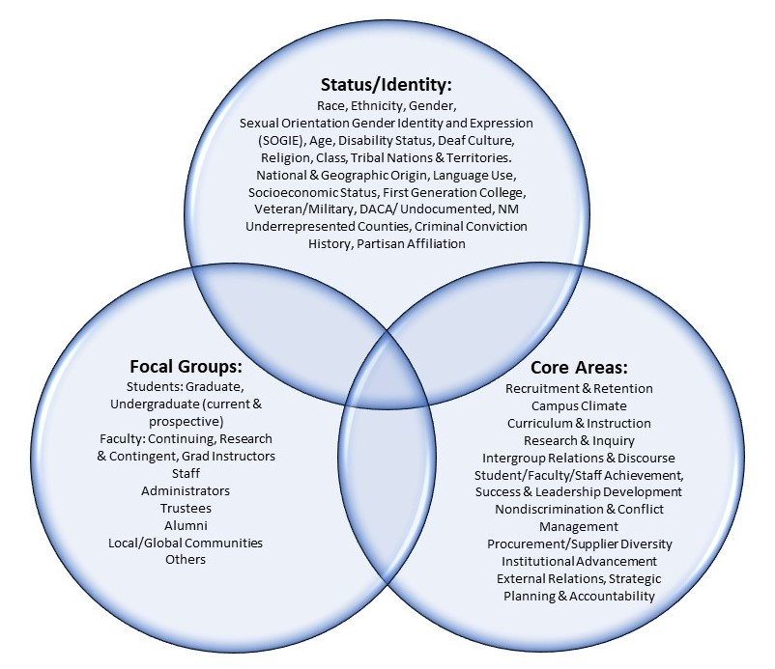

Figure 1. Describing Diversity in Higher Education

Adapted from Three-dimensional model of higher education diversity. Adapted from “Advancing Scholarship for the Diversity Imperative in Higher Education: An Editorial,” by R. L. Worthington, 2012, Journal of Diversity in Higher Education, 5, p. 2. Copyright 2012 by the National Association of Diversity Officers in Higher Education.]

It is important to be explicit at the outset about the community that we want to strengthen. The [National Association of Diversity Officers in Higher Education](https://www.nadohe.org) (NADOHE) offers a three-dimensional model of higher education diversity (Worthington 2012). For equity and inclusion at UNM, it is evident that stakeholders’ social identities and/or characteristics reflect the intersectionality of many social statuses/positions in systems of inequality, including: race, ethnicity, class origin/parental educational attainment (including first-generation/continuing-generation college status), current socioeconomic status, gender, national and geographic origin, immigrant status, sexual orientation and gender identity and expression, foster care experience, unsheltered/homeless status, disability status, religion, nativity, language use, socioeconomic status, immigration status, tribal enrollment status, veteran/military, DACA/undocumented, rural areas of NM and underrepresented counties of the state at UNM, criminal conviction history, and political ideology.

Recent calls for proposals from the National Science Foundation (NSF) have called attention to the critical importance of intersectionality in diversity, equity, and inclusion (DEI) efforts (NSF 2020). To address intersectionality, the types of questions to consider include:

* Though a high percentage of women are gaining entry into jobs in the university, are women of color gaining the same types of promotional opportunities as white men—and are there salary discrepancies when they do?
* How are challenges of successful promotion and tenure amplified for women who also have a disability?
* How about addressing the physical infrastructure and resources for our undergraduate students: Are these designed with women students who are also working mothers or single mothers in mind?

We need to make sure that we are asking these kinds of questions and setting policy and practice in ways that plan for long-term solutions in addition to ways that will facilitate responding to the unexpected. As noted by NADOHE, these social characteristics can be found in various focal groups (as indicated by circle 2 in the above illustration). In fact, it is our goal to diversify the social identities represented in those focal groups. And, to promote their inclusion in core areas such as recruitment that focuses on families and communities—and not just the individual.

Our goal is to create/foster a campus climate that is welcoming, a curriculum that teaches us about ourselves as well as to appreciate the culture of others, instruction that is culturally responsive, procurement practices that encourage the use of minority- and women-owned businesses, foundation work and advancement that promotes alumni engagement from diverse backgrounds, and accountability that includes metrics to assess diversity performance goals.

As shown by National Association of Diversity Officers in Higher Education (NADOHE), equity is the goal. We know that we have arrived at an equitable state when social identity characteristics do not determine access and opportunity—and when there is total inclusion in all core areas (Worthington 2012).

## WHY DOES DIVERSITY MATTER?

For UNM, diversity, equity and inclusion benefit our mission. We know that diverse groups are more productive, creative, and innovative (Herring 2009). Diverse groups generate higher-quality ideas (McLeod, et al. 1996; Loyd et al 2013; de Vaan et al 2015). And the level of critical analysis of decisions and alternatives is higher in groups exposed to minority viewpoints (Sommers, et al., 2006; Loyd, et al. 2013; van Dijk, et al., 2017). That’s why we want our representation at UNM and its Branch campuses to reflect the diversity of the communities where we live and work. We want our people to feel that they belong and are respected—and that they bring value and are encouraged to thrive.

Diversity and inclusion foster innovation (Bell, et al. 2011; Hofstra, et al. 2020). Citing human resource management literature, the Society for Women Engineers (SWE 2014) argues that diversity and inclusion are synergistic. Diversity does not work without inclusion and vice versa. We also know that “decision-making improves when teams embrace different points of view; independence of thought; and the sharing of specialized knowledge…. Diverse groups also do better on sophisticated problem-solving tasks than homogeneous groups because accommodating different experiences breaks down the risk of groupthink…. Groups that make the time to openly discuss conflict and that want to learn from all perspectives can reap the greatest benefits of diversity through the development of an inclusive culture” (Society for Women Engineers and ARUP [a London-based engineering firm] 2014).

Consistent with SWE (2014), educational institutions suffer turnover, missed opportunities, and low morale when they lose someone’s contribution because they feel they don’t belong. Overlooking and underutilizing the full potential of students and personnel happens particularly when unconscious bias is at play. “At their best, diversity and inclusion efforts work together to cultivate an empathetic understanding in leaders and colleagues that allows them to value each other as individuals and as a whole people” (SWE 2014).

# DIVERSITY VALUES STATEMENT

**Overview**

Charge: *establish a university diversity values statement**and create a process for colleges to affirm this statement on an annual basis.*

A Diversity Statement Task Force met in early March 2020 to define, discuss and draft a diversity values statement that would reflect our guiding beliefs as a diverse educational institution. The following draft statement was presented to the UNM Diversity Council in the fall of 2020:

*The University of New Mexico is privileged to sit on Indigenous land. Recognizing the unequal power structure and guided by the principles of equity and justice, we seek to earn trust. UNM commits to critical reflexivity, ethical accountability, and expanding opportunity by cultivating potential & centering the community wealth of the peoples of New Mexico and beyond.*

In order to create an inclusive process of determining and affirming our diversity values as an institution, DEI has engaged faculty and students in the following ways:

* Spring 2021 - Representatives from the UNM Diversity Council met with faculty, staff and leadership across campus. Participants shared value words, phrases and statements that reflect UNM’s inclusive culture.
* Summer 2021 - Incoming students attending New Student Orientation events are invited to answer two guiding questions:

1. How do you define diversity?
2. Why is diversity important in your academic career?

Responses from each week are being gathered and a report will be created at the end of summer to incorporate student voices into the statement.

* Fall 2021 – DEI will present our Diversity Values Statement to UNM Staff Council and request input.

***Current Situation:***DEI will synthesize input from these campus activities to shape a final statement to be confirmed by the UNM Diversity Council in the Fall 2021.

***Recommendations:*** The taskforce recommends that the values of diversity, equity, accessibility and inclusion be fully incorporated into all university policies that articulate the mission of the institution (RPM, UAP 1000, FHB A20). See: Regents policy manual: foreword <https://policy.unm.edu/regents-policies/foreword.html>; Administrative Policy Manual, policy 1000 <https://policy.unm.edu/university-policies/1000/1000.html>; Faculty Handbook, policy A20: <https://handbook.unm.edu/a20/>

***Long Term*:** DEI will invite input to the UNM Diversity Values Statement by:

* Adding a form on our website [diverse.unm.edu](https://diverse.unm.edu/programs/initiatives/diversity-council/diversity-council-subcommittees.html)
* Inviting representatives from each college to attend Diversity Council meetings where the statement will be reviewed each fall.
* Coordinating with the Office of the President and University Communications and Marketing in order to establish a diversity values page officially endorsing the collaborative statement.
* Coordinating with the Faculty Senate, the Faculty Senate Policy Council, the Policy Office, the Office of the President, and the Board of Regents to incorporate the diversity values into the three policy handbooks so they are explicitly stated policy.

# COORDINATION AND COMMUNICATIONS STRUCTURES FOR DIVERSITY, EQUITY, ACCESSIBILITY, AND INCLUSION

DEI has worked toward better coordination and communication of DEAI efforts across colleges and shared diversity goal setting via Liaisons in Equity, Advocacy, and Diversity (LEAD) Council, and biannual meetings with college deans to review DEAI goals for the year, and faculty/staff diversity in the annual affirmative action plan. Spring 2021 DEI offered to meet with all colleges and department to discuss new initiatives. On-demand meetings and presentations are available.

Further, DEI has strengthened equity and inclusion infrastructure through (a) utilizing the Diversity Council to communicate and build campus-wide diversity strategy, and (b) providing support to the college/school-level senior diversity officers, and to college/school-level and unit-level diversity committees. We will institutionalize a student diversity council as part and parcel of this coordination and communications strategy. Further, the student diversity council will expand available leadership opportunities for students, especially URM, women, PWD, and LGBTQIA students. The work of the student diversity council will also inform DEI programming around social justice, diversity, equity and accessibility.

We also recognize that UNM employs a significant number of Spanish monolingual staff or those for whom reading Spanish is their preferred choice. We encourage all units to provide bilingual resources when possible.

**DEI Website Enhancements**

In an ongoing effort to keep the university community up to date on activities and streamline requests for diversity education offerings, DEI is working with to increase accessibility of the website as well as improve timeliness of updates. This includes embedding Formstacks to facilitate requests for diversity education.

**UNM Website Updates**

***Current Situation*:** Many activities are posted in the university website, but their visibility could be enhanced (forums, talks, meetings, conferences, opportunities, events, etc.).

***Recommendations*:** Create tab for events and opportunities related to diversity, equity and inclusion to increase visibility.

***Immediate Action Items*:** We would like to explore creating an “equity and justice events” tab at the upper right-hand corner of two key access points to the UNM portal/website: my.unm.edu and unm.edu website. This includes creating a specific DEAI tab at <https://unmevents.unm.edu/directory>

***Long Term Action Items*:** Ask all departments/program units to revisit their own website and messaging around diversity, equity, accessibility and inclusion (text, images or lack thereof).

# ADDRESSING DEMOGRAPHIC DIVERSITY AND INCLUSION AT UNM

We seek to expand opportunity for our students by cultivating their potential and centering their communities.

We hope to address these goals by engaging a handful of initiatives in the near future.

* **Enriching diverse and inclusive climates in units**
* **Educating colleagues to be better peers, mentors and supervisors to all employees and students**
* **Enhancing our students’ academic success and sense of belongingness**
* **Improving effective support to faculty and staff experiencing bullying and harassment**

We will address each of these below, starting with a review of plans focused on faculty, graduate students, and undergraduates, followed by section E which reviews plans for enhancing UNM’s inclusive climate.

## 1. DIVISION FOR EQUITY & INCLUSION’S STRATEGIC PLAN FOR INCREASING FACULTY DIVERSITY AND INCLUSION AT UNM

UNM is working to increase diversity of facultyfrom underrepresented racial/ethnic minority (URM) groups and women in STEM (with focus on engineering, and physical and mathematical sciences).

In order to better coordinate and communicate diversity, equity, accessibility and inclusion (DEAI) efforts across colleges, in Fall 2019, newly hired UNM Vice President for Equity and Inclusion (VPEI) Dr. Zerai established the Liaisons for Equity, Advocacy, and Diversity (LEAD) council. LEAD is a council of associate deans for diversity or associated positions (recognizing that colleges vary in size and structure) that represent each of the academic colleges on main/ABQ campus; ex-officio members are also invited from Academic Affairs, the Health Sciences Center and UNM Branch campuses, and DEI. The LEAD council’s charge is to work to increase and enhance faculty diversity, equity, accessibility and inclusion at UNM, with a focus on tenure-system faculty. Minimum criteria for LEAD council membership is a demonstrated commitment to diversity, equity, accessibility and inclusion. It is expected that LEAD council college representatives serve on their respective dean’s executive leadership team.

VPEI and the LEAD council created a plan for increasing **U**nderrepresented **R**acial/Ethnic **M**inority (URM) tenure-system faculty at UNM. This plan started with a several-months long discussion to set preliminary goals for minority faculty composition at UNM. The dashboard, a mechanism for tracking each college’s progress in increasing faculty diversity, includes approved goals. It can be found here: <http://oia.unm.edu/facts-and-figures/dei-benchmarking-goals.html>

**UNM DEI and OIA Racial/Ethnic Definitions:** According to the National Science Foundation, **U**nderrepresented **R**acial/Ethnic **M**inority (URM) includeNative/American Indian**,** African American/Black, orLatinx/Hispanic (regardless of racial identification)**.** International refers to thefederal designation of “Nonresident alien” (source: <https://nces.ed.gov/ipeds/report-your-data/race-ethnicity-definitions>). See appendix.

Goals were set by college, due to their wide variation in racial/ethnic diversity of the faculty. We are focused on increasing proportions of URM faculty, given low numbers at UNM even though we are a Minority Serving Institution (MSI). The Association of Public Land-grant Universities (APLU) Student Experience Project (SEP) results show that students at UNM are more likely to report that they have difficulty finding role models at UNM from groups like theirs relative to students from other universities involved in the SEP. And URM students were the group that was the most likely to have difficulty finding role models from groups like theirs relative to white and Asian students. Research indicates that faculty diversity enhances success of all students, that BIPOC junior faculty are more likely to have written innovative dissertations relative to white male faculty (Hosftra et al, in National Academies of Sciences 2020), BIPOC faculty, especially women are more likely to spend time on teaching (Hendrix 1998; 2020; Stolzenberg et al 2019), teach from a growth mindset (versus a fixed mindset), that BIPOC and especially BIPOC women faculty are more likely to have overcome cumulative disadvantages (Reede 2015). This means that hiring URM faculty is a huge asset to any university, but especially to Minority Serving Institutions, because URM faculty by and large bring know-how for navigating academic structures to the benefit of URM students and all students. It is telling that students at UNM report that they are having difficulty finding role models from their own groups. UNM has chosen to respond to this challenge.

Below find a table that provides an overview of all assistant, associate and full professors at UNM (including ABQ/Main, HSC, and Branch campuses) by race/ethnicity (October 2020). Please note that regardless of race, any individual indicated that they are Hispanic or Latino are counted as Hispanic below.



Table 1. **University of New Mexico, Main Campus Underrepresented Racial/Ethnic Minority (URM) Tenure-System Faculty, October 2020.**

While a number of colleges have zero URM faculty in material (full-time equivalent of .5 or higher) tenure-system appointments, or fewer than 3%, a few are doing relatively well when we examine percentages, including the College of Architecture and Planning, Law, Education and Human Sciences, and Honors College. But even some of these still have very low numbers of URM faculty in tenure-system lines (i.e. full time equivalent--FTE) (e.g. Honors College with a small overall number of faculty has only 2 URM faculty). In order to track our improvements in these numbers, it is important to set goals. We used a formula to set goals. If current disaggregated proportions of faculty members who are Native American, Latinx, or Black are 0, 1%, or 2%, try to increase *to* baseline of 4% (==2 people in a college of 50%. If proportion is currently 3% or 4%, try to increase *to* at least 5%. All else, college deans agreed to try to increase *by* 25%. Target dates are FY2027. The exception is Arts and Sciences, which has requested a target date of FY2030. And some colleges have established internal goals that are more ambitious.

Placing faculty diversity in regional and national context, a sampling of peer institutions from the Integrated Postsecondary Education Data System (IPEDS) 2019 shows we are doing relatively well when it comes to Latinx/Hispanic, and Native American faculty. In fact, we rank number one for the highest percentage of Native faculty and 6th for the percentage of Latinx faculty. But we lack faculty diversity when it comes to African American faculty. Our rank is 21 out of 23 institutions when it comes to African American/Black faculty. However, our actual numbers (FTE) of Native American faculty are relatively low at 28 in 2019; Black faculty were only 11; whereas only 115 Latinos were tenure system faculty in 2019, out of a grand total of 844 tenure system faculty at UNM.

Given these facts, after establishing goals, we designed the following strategy to improve overall composition of URM faculty at UNM. VPEI worked with LEAD to identify challenges to building and sustaining faculty diversity. These included:

1. implicit bias in hiring,
2. the need for a roadmap to the professoriate for underrepresented racial/ethnic minority (URM, to include individuals who are Native American, Black, and Latinx) postdocs and visiting scholars through a revitalized postdoc program,
3. the need for bridge funding to support tenure-track faculty hiring of URM and women in STEM (with focus on mathematical and physical sciences, and engineering), and
4. the need for resources to help retain faculty and support their scholarly endeavors.

DEI established several resources to address each of these challenges. They include:

1. Making the DiversityEdu online course available to faculty search committee members; this online course which provides implicit bias awareness and mitigation strategies, along with tools for implementing diversity-competent searches, and is required for faculty research committee members starting AY21);
2. Establishing the Inclusive Excellence Postdoc and Visiting Scholars Program; the central feature of this new program draws from the National Center for Faculty Development and Diversity (NCFDD) resources and other best practices to require a substantive mentoring plan; the program also provides incentives to senior faculty to receive diversity education, so they will be more effective mentors to postdocs and junior faculty (for main campus tenure-granting departments);
3. Establishing Inclusive Excellence bridge funding to support hiring of URM tenure-track faculty (main campus); the hiring program also requires a substantive mentoring plan, as mentioned above; and
4. Purchasing the annual National Center for Faculty Development and Diversity institutional membership (available university-wide, including HSC and branches), including offering Faculty Success Program (FSP) Scholarships; FSP is a 12-week boot camp that promotes and guides participants in practicing empirically tested methods to improve research productivity through intense accountability, coaching, and peer support; FSP scholarships from DEI are available to main campus and HSC tenure-system faculty; NCFDD provides resources and support for extraordinary research productivity and work-life balance. For more information, see <https://diverse.unm.edu/resources/faculty/ncfdd.html>

Results 2020-21

In 2020-21 (even under pandemic conditions) there has been an enthusiastic response from faculty and college administrators to DEI’s plan for faculty diversity which has produced these advances.

1. DiversityEdu

In 2020-21, DiversityEdu was offered to 119 faculty, staff, and other individuals who served on faculty search committees; 61 completed it and 6 are in progress. It is our hope to increase the number of completed courses to a total of 200 faculty by January 2023. Goals for future benchmarks (2027, 2035, and beyond) will be set once we have a better sense of UNM’s future faculty hiring plans.

1. Inclusive Excellence Postdoc and Visiting Scholars Program

The revamped Inclusive Excellence Postdoc and Visiting Scholars Program has been in operation since spring 2020. In that time, six postdocs have been hired. One completed her postdoc and began her role as assistant professor fall 2020. One is continuing to her second year starting fall 2021. And the other four were selected spring 2021 and will begin their appointments fall 2021. Please see results in Table 2 below.

1. Inclusive Excellence bridge funding to support hiring of URM tenure-track faculty

DEI is working with Academic Affairs concerning the details of this program. Academic Affairs will set the rules for the new targets of opportunity hiring program. VPEI and the LEAD council will determine criteria and application process for the hiring program once we receive more details from Academic Affairs. However, we have been able to pilot the program by contributing toward the hire of a new assistant professor who will begin fall 2021. Please see results below.

|  |  |  |  |  |  |  |
| --- | --- | --- | --- | --- | --- | --- |
| **Academic Background and Prospective Appointment** | | | **Postdoc Offers** | | **All Finalists** | |
| **URM (Black; Native American /Indigenous; Latinx/Hispanic** | **Ph.D. or Terminal Degree Institution** | **Field of Study** | **College & Department** | **Disposition** | **Round** | **[Prospective] First Year /Semester** |
| Black/African American female | University of Texas at Austin | Performance as Public Practice | Fine Arts, Theatre and Dance | Awarded & Accepted | 1 | Fall 2021 |
| Native American male | CU Boulder | Comparative and indigenous politics | A&S, Political Science | Awarded & Accepted | 1 | Fall 2021 |
| Black/African American female | Univ of Florida | Materials Science & Engineering | Engineering, ECE | Awarded & Accepted | 2 | Fall 2021 |
| Hispanic male | Massachusetts Institute of Technology; Columbia University | Architecture | School of Architecture & Planning | Offered; Degree pending | 1 | Fall 2021 |
| Native American female | Univ of NM | American Studies, conc Art History | Fine Arts, Art History | Continuing | NA | Fall 2020 |
| Afro-Latina female | Univ of NM | Spanish & Port; Afro-Mexican Studies | A & S, CCS | Assistant Prof in CCS Fall 2020 | NA | Spring 2020 |
| Black/African American female | University of North Carolina at Greensboro | Studio Art | Fine Arts, Art & Art History | Assistant Prof Fall 2021 | NA: Hiring Program pilot | Fall 2021 |

Table 2. Inclusive Excellence Postdoc and Visiting Scholars Program and Inclusive Excellence bridge funding to support hiring of URM tenure-track faculty

1. NCFDD memberships and Faculty Success Program (FSP) scholarships

The National Center for Faculty Development and Diversity has been an important resource for faculty at UNM ABQ/Main, HSC, and Branch campuses. Currently we have 542 faculty at UNM registered for NCFDD memberships. DEI has been able to offer Faculty Success Program writing bootcamp scholarships to eleven faculty. Scholarships covered approximately half of the cost of the FSP. Academics units helped faculty cover the other half.

* In 2020-21 DEI awarded 8 scholarships to recipients in A&S (5), Law School, Anderson School of Business, Architecture, and Honors College.
* And in 2021-22 DEI awarded 3 scholarships to recipients in Honors College, Fine Arts, and the College of Education and Human Sciences.

It is our hope to increase to NCFDD memberships to 1000 faculty, and to offer 10 FSP scholarships to ABQ/Main and HSC faculty annually. And we would like to explore opportunities to offer FSP scholarships to Branch campus faculty. See brochure for more information. <https://diverse.unm.edu/assets/docs/ncfdd-faculty-success-program.pdf>

Hiring URM faculty is vital, however it is also important to retain them. DEI works with campus partners to continually address campus climate issues that are relevant to faculty. A small sample includes:

* DEI has been fortunate to work with the Native American Faculty Council, and Director of American Indian Studies Services, Pamela Agoyo who have written the UNM’s official Land Acknowledgement statement, which was adopted by President Stokes UNM Spring 2020. The UNM Land Acknowledgement is now read at all Board of Regents meetings, as well as at a variety of high-profile as well as regular UNM events and committee meetings. For more information, see <https://diverse.unm.edu/about/land-acknowledgement.html>
* DEI is working to streamline/enhance support to faculty targets of harassment, including sexual harassment, bullying and violence at UNM. DEI is developing a website to assist faculty (and staff) to privately navigate UNM resources for support and reporting misconduct, and is working with campus partners to create an integrated conflict management system.
* Additionally, we are leading a Black Faculty Truth Commission to address bullying, harassment, and violence against Black Faculty.
* DEI has created UNM’s new *Guidelines for Preventing and Responding to Doxing, Trolling, Zoom bombing*, and other hazards of web meetings, [https://webmeetings.unm.edu](https://webmeetings.unm.edu/) and <https://webmeetings.unm.edu/online-safety/responding-to-incidents.html> ; collaborators include: VPEI, IT Security, Academic Technologies, and OEO.

Recommendations to other units concerning faculty diversity:

1. It is DEI’s hope to work with Academic Affairs on targeted hiring programs along with a UNM dual career hiring program for academic couples and proposes support for identifying (not funding) off-campus employment for partners of tenure-system hires. These could be especially important for recruitment and retention of high-potential faculty at UNM.

Since 2014, the previous Provost mandated that all faculty searches under the jurisdiction of Academic Affairs (Main and Branch Community College campuses) include as a preferred criteria the candidate's "demonstrated commitment to diversity, equity and inclusion and student success as well as working with broadly diverse communities.” DEI recommends that this mandate be incorporated into the Faculty Handbook and corresponding administrative procedures. Further, DEI recommends exploration of a commitment to diversity equity, accessibility, and inclusion as a *minimum criteria* for all faculty hires at UNM, given that we are a minority-*serving* institution. We recommend updated language in job advertisements as follows, “evidence of demonstrated and sustained commitment to diversity, equity, accessibility & inclusion as well as working with broadly diverse communities.” Further, we recommend that academic job postings require applicants to submit materials to provide evidence of this commitment. Possible language offered by a colleague in the College of Education and Human Sciences (COEHS) follows: “Please submit a one-page statement where you articulate how you have demonstrated your commitment to issues of equity, inclusion, and diversity in your scholarship, teaching, and/or service. Please include how you might demonstrate this at UNM and in the COEHS. For example, you may have worked with members of a marginalized or underrepresented community, a local community organization, or your current institution.”

## 2. GRADUATE STUDIES PRELIMINARY STRATEGIC PLANNING FOR EQUITY AND EXCELLENCE

[Submitted by Grad Studies Associate Dean Jesse Alemán]

**Overview**:

With a broad purview over graduate programs, Graduate Studies is primarily a transactional office that sees to graduate student academic completion (advising, programs of studies, dissertation committees, etc.). It also processes assistantship contracts that have been generated and approved at the department level. As for student funding, Graduate Studies offers the Winrock-Regents minority recruitment award; the Charles Griffith Fellowship in Science and Technology (new); the Glenda Lewis Critical Race Scholars Award (new); graduate student travel and research grants; and a nominal dissertation fellowship (the Dean’s Dissertation fellowship). Excellence Assistantships and Success Scholarships are allocated to the colleges/schools based on their head count, and the New Mexico Higher Education Department scholarship is awarded to encourage and support the recruitment or retention of underrepresented New Mexico residents. Graduate Studies also offers annual funding for new graduate student outreach and recruitment, including campus visit funds and the Supplement Recruitment Awards. In the administration of these latter awards, underrepresented minority student status is listed as a either a requisite (Winrock-Regents) or a primary preference (recruitment funds). Finally, there is a Doctoral Minority Loan for service program that has funding from the state legislature. There are about two dozen faculty on campus here through this program

Several key areas remain critical to Graduate Studies’ Strategic Planning: outreach and recruitment; current student support toward graduation; institutional climate and culture; creating community of practice around high-impact strategies for diversifying doctoral studies (e.g., holistic review and revisit the use of standardized entrance exams such as the GRE).

### OUTREACH AND RECRUITMENT:

Graduate Studies’ purview in outreach and recruitment initiatives remains largely in providing limited resources to those departments that request funding support. On average, Graduate Studies can provide a relatively small fraction of the support requested, due to limited budget and widespread requests. All outreach and recruitment efforts, however, fall in the hands of departments and programs, some of which have well-funded staff efforts while others have no infrastructure to tend to outreach and recruitment. Outreach and recruitment efforts would likely be more strategic and successful with sustained, concerted initiatives launched at the department and faculty levels.

***Immediate Plans:***

1. Continue to facilitate departmental outreach efforts by providing targeted spreadsheets from the National Name Exchange and the McNair Scholars database.
2. Continue to support targeted post-admission minority student recruitment through Incentive Awards and Diversity and Distinction recruitment awards.
3. Build and enhance available resources for outreach platforms (videos), events (remote open houses in the fall); and Project for New Mexico Graduates of Color (PNMGC) ambassadors.

***Current Trends:*** Total graduate enrollment has declined from 6,939 in 2015-2016 to 6,489 in 2019-2020 (2020-21 numbers have yet to be finalized). Within this trend, the number of self-identified white students has declined from 3,132 to 2,730, while the number of Hispanic students has increased from 1,805 to 1,929 over the same span. International students have seen decline from 928 to 770. Enrollments for American Indian and Black students remain relatively stagnant, from 280 to 295 for the former and from 143-141 for the latter. Asian student enrollment moved from 259 to 282.

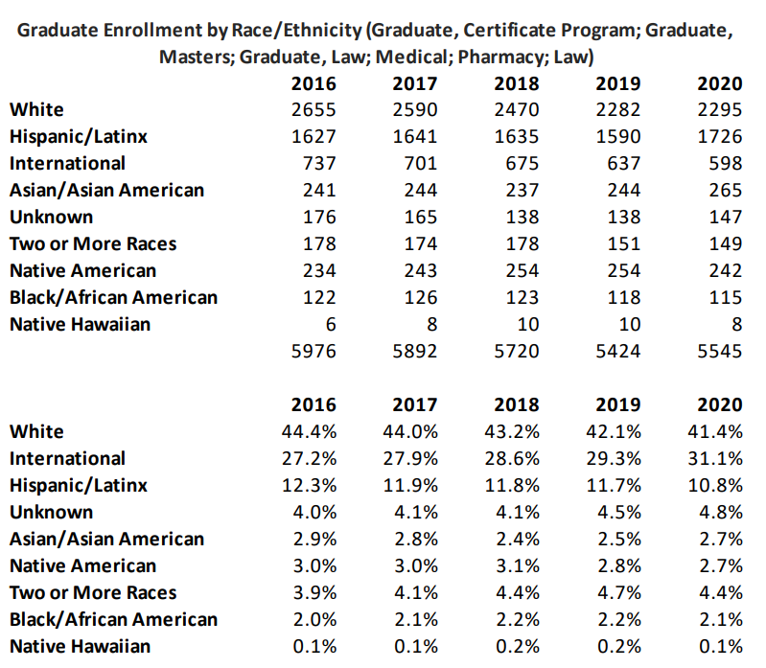

Table . Graduate Enrollment by Race, Ethnicity (Graduate programs including Law, Medical, Pharmacy, Certificate, Masters)

***Target Goal:***

1. Increase overall graduate student enrollment by 10% to rebuild and recover from enrollment losses over the last 5 years.
2. Continue to sustain and support Hispanic student enrollment trends at their growth rate (6.8%), especially at the doctoral level, where Hispanic students are underrepresented in light of their overall steady enrollment numbers (over the last five years, they have seen a decline from 311-283).
3. Increase American Indian enrollment trends to 10% (current rate is roughly 5.3%)
4. Increase Black enrollment trends by 5% (current rate is -1.3%).
5. Create a *Crossing Latinidades* graduate student database and pipeline initiative (similar to the SNL-UNM Minority Student Success Program).
6. Create a dedicated Minority Dissertation Writing Award for increasing completion rates of URM graduate students, with a particular emphasis on those who are did not grow up in households where one parent earned a four-year college degree (Morgan et al., 2021).

UNM must make a concerted effort across all graduate units to increase Native American and Black doctoral student recruitment, retention, and graduation through specific scholarships, innovative department funding models, department or college sponsored outreach and recruitment at strategic campuses

(<https://www.indian-affairs.org/native-studies-list.html>) and HBCUs (<http://www.thehundred-seven.org/hbculist.html>); and collaborative faculty mentoring practices to support students across disciplines.

**Focused Areas of Improvement: Doctoral Enrollment & Department and Faculty Involvement**

1. Between 2015 and 2020, white students accounted for almost half of all doctoral students (48.5% & 48.7% respectively), while Hispanic students, who saw an overall steady growth in graduate student enrollments, saw a considerable enrollment decline over the same span: 19.3% in 2015 and 12.1% of all doctoral students in 2020. American Indian students likewise declined from 1.5 to 1% of the total doctoral cohort, and Black students also saw a decrease from 1% to .5% in 2020. In raw numbers, this means in 2020, we had one self-identified Black student out of 199 doctoral students; 2 American Indian students; 24 Hispanic students; and 97 white students.

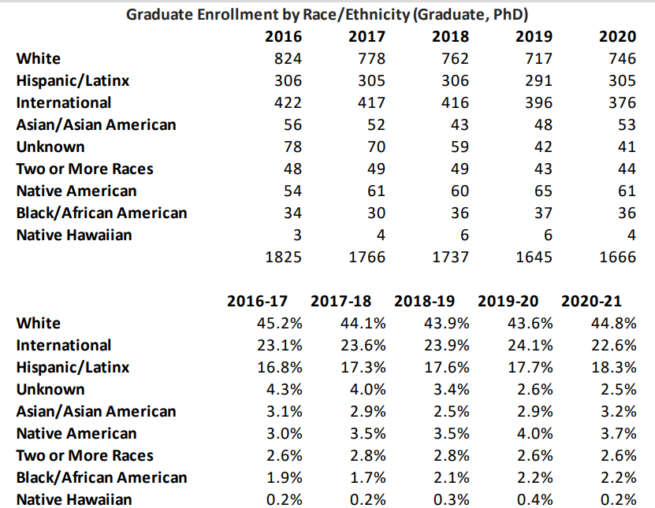

Table . Graduate Enrollment by Race, Ethnicity (Graduate, PhD)

1. Outreach and recruitment programming and initiatives vary dramatically across and with the Colleges. The School of Engineering, for example, maintains a robust year-round outreach and recruitment effort, while in the College of Arts and Sciences, such efforts occur at the department or program level. As such, these efforts benefit those departments and programs with the funds, staff, and faculty commitment toward outreach and recruitment. A major area of improvement, then, would be to support a more equitable system of outreach and recruitment for all departments and programs and to tie such efforts to bias training, demonstrated faculty commitment to mentoring, and the institutional climate record of the department or program.

### SUPPORT CURRENT STUDENTS:

Graduate Studies has recently made strides in front-lining underrepresented minority students in major, pilot programs such as the UNM-Sandia collaboration and the Dr. Glenda Lewis Critical Race Scholars award. However, minority graduate student matriculation rates would be positively served by completion awards in conjunction with start-up funds, especially in the humanistic social sciences. Data shows stark difference between the numbers of minority students admitted to graduate programs versus the percentage who complete their degrees, and in light of overall increased Hispanic enrollment trends, the number of doctoral degrees conferred remains drastically low. However, many institutions struggle with this. For example, whereas 29% of Latinos at UNM were enrolled in graduate programs in 2018, resulting in UNM’s rank of 4th highest percentage of Latino graduate students enrolled relative to 22 peer institutions (same rank in 2019), and 25% of doctoral degrees were conferred to Latinos in the same year, resulting in UNM’s rank of 3rd highest percentage of Latinos awarded doctorates, relative to peers. This is out of 519 degrees awarded to UNM doctoral recipients in 2018.

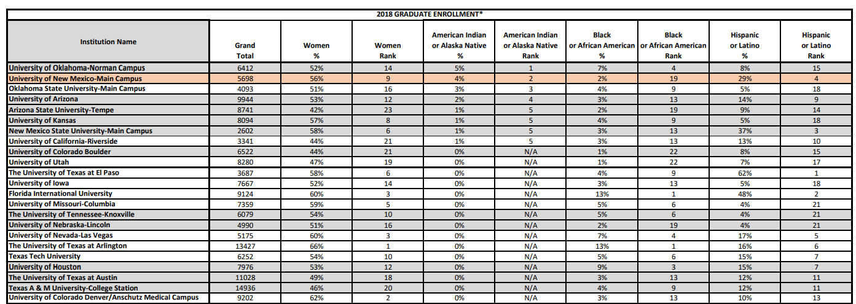

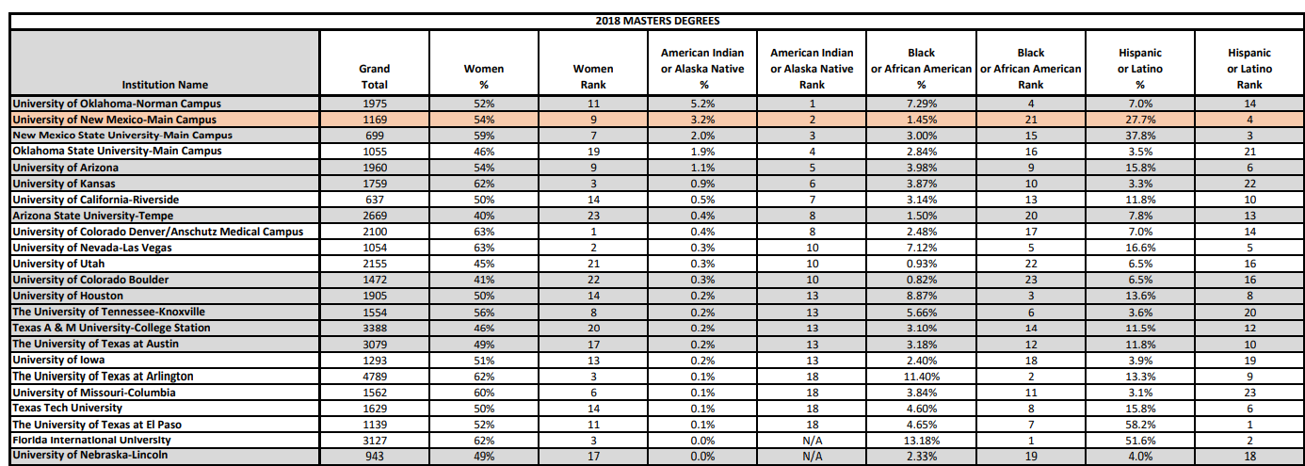

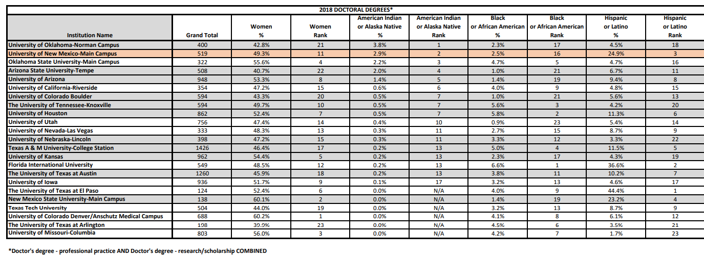

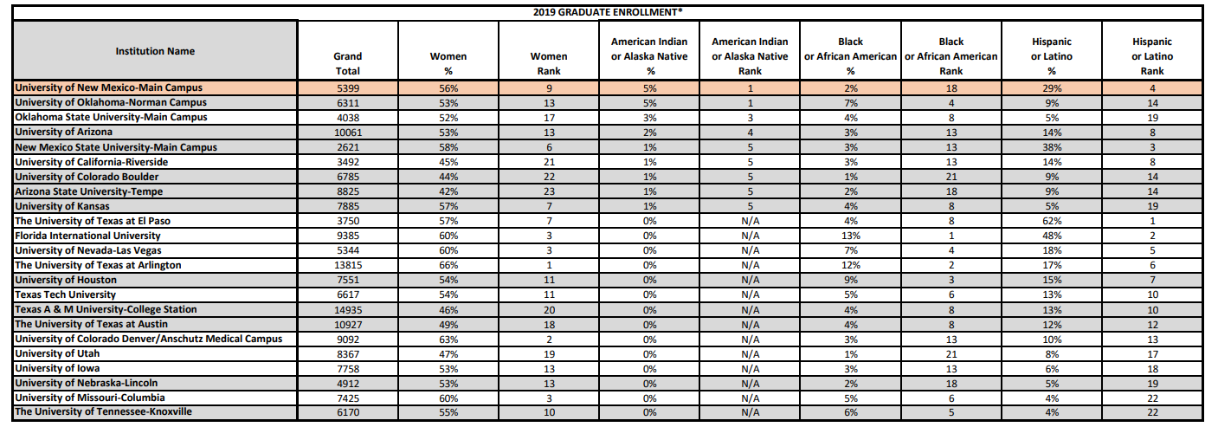

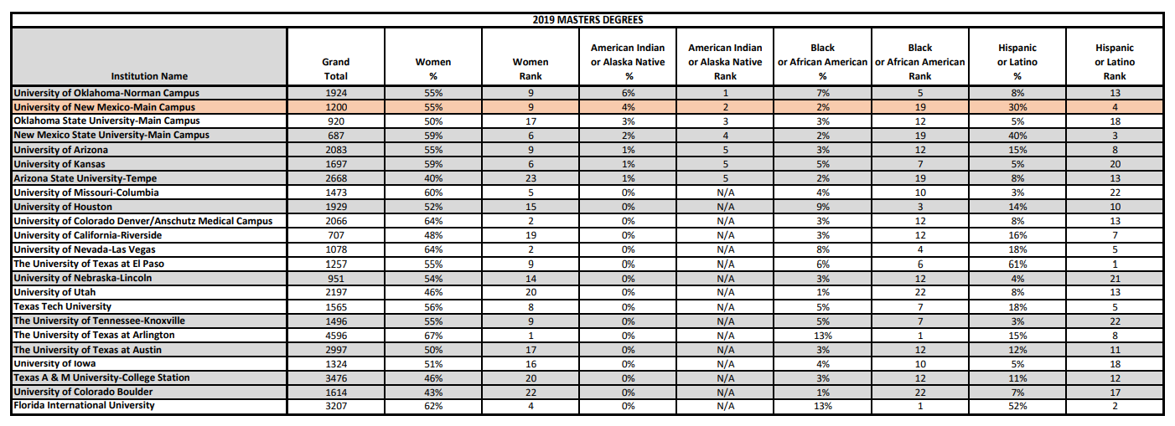

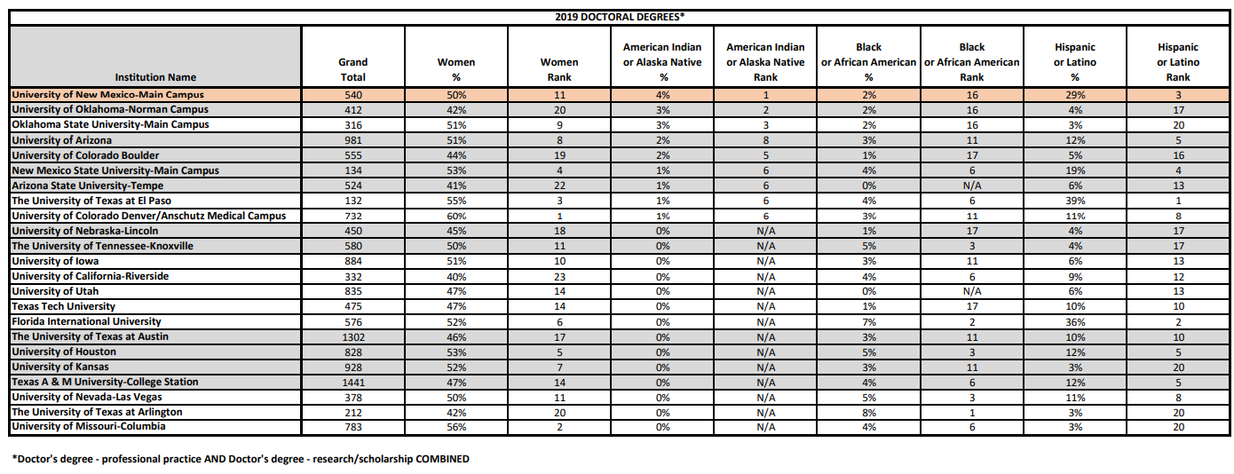

Table . 2018, 2019 Graduate Enrollment and Doctoral Degrees Conferred

***Immediate Plans:***

1. Continue to utilize the NMHED funding for underrepresented minorities to full extent.
2. Continue to provide travel and research grants for conference presentations, field or archival research, art presentations, etc.
3. Continue and enhance the role of Professional and Academic Workshops (paw.unm.edu) to coordinate and advertise graduate-student related workshops offered by various entities on campus.
4. Formalize and continue UNM-Sandia Minority Graduate Student Success and the Glenda Lewis Critical Race Scholars programs.
5. Enhance PNMGC’s programming to include faculty cohorts for minority-student mentoring
6. Proactive public-facing of minority student research, accomplishments, and opportunities.

***Current Trends:*** Five-year graduation rates not yet available for this report. However, degrees conferred in 2018 and 2019 are presented above.

***Target Goal:***

1. Revisit Winrock-Regents recruitment award to support or enhance dissertation completion award.
2. Revisit the funding model of the Graduate Dean’s Dissertation Award to increase the amount of its current award ($8000) or offer two awards at that same amount.
3. Improve graduation rates by 10% among all underrepresented groups
4. Increase peer and faculty mentoring and student-support initiatives by improved programming and required training for faculty. Ideally, GS to provide or facilitate such training in a way that compensates, awards, or formally recognizes such training as relevant and significant for faculty review (merit, tenure, promotion, etc.).
5. Increase & establish forms of summer writing-research funding to fund 12 dissertation (PhD/MFA) awards at $5,000 for the summer.
6. Develop the summer writing award to include faculty advising or mentorship over the summer via extra compensation or related forms of support to encourage faculty involvement and recognize it as relevant and significant for faculty review (merit, tenure, promotion, etc.).
7. Diversify the summer funding initiative to include master’s thesis or portfolio completion or “start-up” summers to begin the writing of a dissertation/MFA.
8. Broaden the summer funding initiative to receive support from colleges and programs so that the award is not solely out of GS budget line.
9. Create diversity, equity and inclusion subcommittee of the Diversity Council for graduate directors for sharing promising practices (e.g., first generation college status data collection for applicants and enrolled students, revisiting the use of standardized exams such as the GRE, etc.)

### INSTITUTIONAL CLIMATE AND CULTURE

In its current role, Graduate Studies has little administrative reach or leverage to change departmental climates and cultures, though students and faculty often come to Graduate Studies with such requests. At best, Graduate Studies can invite graduate directors and department chairs to a community of practice to share best practices, provide support or encouragement, and advise on the academic impact of any proposed changes. In this capacity, Graduate Studies would do well to continue to play a supporting role in initiatives, interventions, and innovations that originate at the department level. However, it would serve students, departments, and graduate education better if Graduate Studies could take a more proactive stance on some of the issues that inhibit graduate student academic success and achievement, including issues of discrimination, harassment, and structural or institutional inequity.

**Immediate Plans:**

* 1. Continue to encourage and support programming for departmental conversations and review curricular and milestone requisites.
  2. Continue and enhance work with programs during their Academic Program Review to address equity and excellence.
  3. Continue to provide resources on our website related to best practices.
  4. Encourage additional departments to envision summer research award funds
  5. Encourage and support programming for departmental conversations and review of curricular and milestone requisites.
  6. Proactive engagement with advocating student equity and inclusion best practices (see Cornell’s practical steps: <https://gradschool.cornell.edu/diversity-inclusion/faculty-resources/practical-steps/>).
  7. Continue to bring the Graduate Studies dashboard to the attention of graduate programs so they can track their enrollments and degree production by demographics such as race, gender and first-generation college status (Morgan et al., 2021).
  8. Continue to pursue external funding for programmatic initiatives that seek to change graduate curricular climate and culture.

***Target Goals:***

1. Build steady lines of communications with graduate and program directors as well as direct lines of communication with graduate students and assistantship holders.
2. Develop and house a best-practice mentoring plan for students and faculty that addresses issues of access and equity.
3. Adopt and implement the [Council of Graduate Schools](https://cgsnet.org/ckfinder/userfiles/files/CGS_JED_Grad%20Student%20Mental%20Health%20Report.pdf)’ recommendations for addressing graduate student mental health and wellness.

## ADVANCING UNDERGRADUATE STUDENT INCLUSION AND SUCCESS

As a minority-majority, Hispanic-serving and Carnegie Community Engaged institution, The University of New Mexico strives to provide equitable educational opportunities. UNM’s undergraduate demographics of our enrolled students at the UNM Main Campus mirror those of the state: 45% Hispanic, 33% White, 5% Native American, 4% Asian, 3% Black. Yet, challenges remain in terms of translating this demographic diversity into equitable outcomes. Below, Table 4. provides a snapshot of graduation rates by race and ethnicity for all UNM Main Campus students and reminds us of a persistent gap in graduation whereby Native American, Hispanic/Latinx men and women continue to experience lower levels of graduation than their white counterparts, particularly if they grew up in households where a parent/guardian did not earn a baccalaureate degree. It is also important to note that the proportion of first-time, first year students that are first-generation college status by race. While the overwhelming majority of white students at UNM grew up in a household where at least one parent earned a four-year college degree, nearly half or more than half of Black, Latinx and Indigenous students grew up in a household where no parent had a 4-year college degree.



Table 6. UNM Main Campus five-year BA degrees 2015-2020

A 2020 report from the New Mexico Legislative Finance Committee (LFC) highlights the urgency of moving from data management for compliance to data mining for impactful innovations (Legislative Finance Committee 2020):

*“The Legislature, HED [Higher Education Department], and HEI [Higher Education Institute] need clear, comprehensive information on college performance and student outcomes. More importantly, college administrators – who have access to troves of data – have the opportunity to mine their databases to identify and produce meaningful information about student success. Leaders in higher education, who shift from a mindset of data-management-for-compliance to data-mining-for-business-intelligence, will disrupt and innovate on college campuses.”*

This report is important because it talks about the importance of innovations in data analysis that can help catalyze equity innovations for impact. One such innovation is reporting complex within-group inequities in graduation by race-gender-first-generation college status as inseparable. See also López et al., 2018; Erwin et al., under review, López 2021 for more information.

### BUILDING CAPACITY AMONG GATEWAY INSTRUCTORS IN STEM

***Current Situation*:** STEM gateway courses have high failure rates, and success gaps among African American/Black, Hispanic/Latinx and Native American students. Growing evidence shows that even when URM students reach the same level of achievement in STEM classes as measured by Advance Placement scores in high school, they are more likely to leave STEM fields as majors, pointing to questions about whether there could be innovations in pedagogy and research approaches that could center the cultural wealth of URM students through pedagogy and other teaching innovations (Reigle Crumb et al., 2019; Garcia-Olp et al., 2020).

In partnership with the Provost Office as well as other units on campus, the Division for Equity and Inclusion is proud to offer several programs that hope to ameliorate this situation:

* *The Student Experience Project*offers faculty easily implemented tools to support students in the classroom by creating an inclusive environment for resilience and persistence. APLU and Raikes Foundation.
* *Expanding Course-Based Undergraduate Research Experiences (ECURE)* introduces students in STEM to general education courses to entry-level undergraduate research experiences, with the goal of providing equitable, engaging and inclusive access to research and investigation.
* *Grand Challenges Faculty Fellows.* New lower-division courses to engage students in grand challenges research. UNM. 4 Faculty.
* *Lobo Connect Summer Bridge.*18 free one-credit courses to assist with entry and placement. UNM.
* *Peer Learning Facilitators.*Students are trained to support peers in courses in which they have shown resilience.
* *Provost Race and Social Justice Teaching Fellows.* Cultivate culturally responsive teaching through communities of practice that are centered on race and social justice.

***Recommendations*:** We will continue building gateway interventions that foster a sense of belonging, cultivate a science identity and create research experiences for undergraduate students and especially those from underserved populations.

***Immediate Action Items:*** Advertise all of the aforementioned programs as opportunities for cultivating communities of practice around culturally relevant teaching and innovations in teaching (Boveda and Weinberg 2021).

***Long Term Action Items*:** 1) Create communities of practice across gateway STEM courses across UNM Branch Campus and Main Campus Faculty. 2) Present Racial and Intersectional Microaggressions (RIMA) survey results and provide opportunities to practice interrupting microaggressions as a part of workshops to STEM faculty and activities within communities of practice. 3) Explore grant opportunities with the Crossing Latinidades (R1-HSI) interuniversity consortium targeting the opportunity gap for Latinx and other URM students.

### STRENGTHENING THE IMPACT OF THE US & GLOBAL DIVERSITY EQUITY & INCLUSION UNDERGRADUATE UNIVERSITY-WIDE REQUIREMENT

***Current Situation*:** The U.S. & Global Diversity & Inclusion 3-credit undergraduate university-wide graduation requirement was established in 2014. Initially courses were approved by meeting one of the four learning outcomes. In the spirit of continual improvement and focus we have updated our syllabi checklist and catalog description to state that courses that document disparities with no critical engagement explanations for disparities do not meet the learning outcomes.

This requirement is overseen by faculty that have a dedicated publication/teaching and service record in equity and inclusion that are appointed to the Curriculum Committee by the Vice President for Equity and Inclusion. The syllabus checklist has been updated to clarify that three of four learning outcomes must be met for all courses seeking approval going forward, beginning 2021-2022 catalog (previously only two of four learning outcomes were required).

***Recommended Partners***: The Faculty Senate Operations Committee, Committee on Governance, Faculty Senate Policy and Curriculum Committees, Africana Studies, Native American Studies, Chicana and Chicano Studies, Women, Gender, and Sexuality Studies, Institute for the Study of “Race” & Social Justice

***Recommendations*:**

* Continue providing office hours for individual faculty interested in teaching courses that meet the learning outcomes for the U.S. & Global Diversity and Inclusion requirement
* Provide a workshop at the beginning of each Fall semester for providing basic information about the submission of courses and learning outcomes for the U.S. & Global Diversity and Inclusion Requirement
* Meet with appropriate faculty governance bodies to explore how to incorporate the Diversity Council Curriculum Committee as a subcommittee of the Curricula committee of the Faculty Senate
* In Fall 2021 the Diversity Curriculum Sub-Committee of the Diversity Council will work with the Faculty Senate Curricula Committee (FSCC) to propose a new policy creating Diversity, Equity & Inclusion subcommittee of the Faculty Senate Curricula Committee.

***Long Term Action Items*:** Explore possibility of creating U.S. & Global Diversity and Inclusion requirement for all UNM Branch Campuses. The University of Pittsburgh, Emory University, California State University, Oregon State and other universities have created dedicated requirements for all undergraduates on antiracism and/or ethnic studies. Arizona State University requires a total of three classes or nine undergraduate credits in equity and inclusion.

### RACIAL AND INTERSECTIONAL MICROAGGRESSIONS (RIMA) SURVEY: CLIMATE ASSESSMENT FOR UNDERGRADUATE, GRADUATE, AND PROFESSIONAL STUDENTS

***Current Situation*:** Research has shown that racial and intersectional microaggressions (RIMAs), “brief and commonplace daily verbal, behavioral, or environmental indignities, whether intentional or unintentional, that communicate hostile, derogatory, or negative racial slights and insults toward people of color,” PWD, & Queer and Trans folks (Sue, et al., 2007) are a threat to inclusive climates in higher education. Though RIMAs can be subtle and may be dismissed by perpetrators (Harwood, et al 2010, 2012), their effects can affect Black, Indigenous, and People of Color (BIPOC, to include Latinx/Hispano, Asian American and Pacific Islander (AAPI), and multiracial individuals) emotionally and physically (Pierce 1969, 1970, 1974; Solorzano 1998; Sue, et al 2003; Sue 2010). Unfortunately, RIMAs create inequities in education, employment, health care, and housing. RIMAs and bias reproduce structural inequality in ways that are “invisible” at an institution of higher education. Research shows that RIMAs:

* Limit access to research assistantships (Moss-Racusin, et al., 2012**)**
* Decrease quality of letters of recommendation (Madera, et al., 2018)
* Limit reviewers for papers and grant proposals (Hostra et al., 2020)

And other deleterious RIMAs and their affects are:

* Students told to drop classes or switch majors (Lewis, et al., 2019)
* Students may withdraw from interactions with faculty, TAs & staff - miss out on key social capital (Nadal. et al., 2014; Lewis, et al., 2019)
* Students may leave the university (Lewis, J.A., et al., 2019; Williams 2019, 2020)

The **R**acial & **I**ntersectional **M**icro**a**ggressions online survey (**RIMA**) explores the experiences of **BIPOC** (**B**lack, **I**ndigenous and **P**eople **o**f **C**olor, to include individuals identifying as Asian/API, Latinx, and/or Multiracial), **P**ersons with **D**isabilities (**PWD**), and **L**esbian, **G**ay, **B**isexual, **T**ransgender, **Q**ueer/**Q**uestioning, **I**ntersex and **A**sexual (LGBTQIA) undergraduate and graduate students at UNM. The RIMA survey (N=514) was administered in Spring 2021 and we will conduct focus groups in the Fall 2021. See <https://campusclimate.unm.edu/initiatives/rimasurvey.html>

This project adds to the burgeoning racial microaggressions literature (Sue et al 2007; Lewis 2019) by describing how such experiences are shared by students who are persons with disabilities (PWD), and who are LGBTQIA *and may be amplified* when a student occupies a combination of marginalized social locations.

Further results will inform tools for interrupting racial and *intersectional* (PWD- and LGBTQIA-focused) microaggressions to faculty and other colleagues in student and academic affairs, with the hope that we can work collectively to become more effective mentors, lab leaders, and instructors and thus improve the learning environment for students in higher education.

***Recommendations*:** Use the findings from these surveys to develop interventions and provide students with resources to navigate and transform these microaggressions.

***Immediate Action Items*:**

* Use the results of the Spring 2021 RIMA survey to better understand students’ experiences in the classroom so we can further appropriate interventions that will be shared with department leaders as well as leaders in the college.
* Conduct Fall 2021 focus groups with students to learn more about their experiences.
* Deliver RIMA workshops to 30 distinct units and present RIMA findings to at least 15 additional units.

***Long Term Action Items*:**

* Share strategies for interrupting racial and intersectional microaggressions.
* Examine the changes in student climate survey results across time by evaluating the findings every 4 years.
* Critical reflections and accountability at the individual, unit and college level can contribute to institutional transformation that advances an inclusive campus climate.

### CREATE A DIRECTORY OF BLACK, INDIGENOUS, AND PEOPLE OF COLOR (BIPOC) FACULTY AND STAFF

***Current Situation*:** Students, particularly those in STEM, have no way of identifying mentors that come from underrepresented backgrounds.

***Recommendations*:** Create a directory of all BIPOC faculty/instructors and staff in a college, department/program. Besides race, gender, ethnicity, rank, we will also ask BIPOC faculty and staff if they want to publicly be identified as first-generation college status, Persons with Disabilities, and/or LGBTQIA. Faculty will be invited to opt in based on their self-identified race and ethnicity data in UNM administrative records. The directory will be updated regularly and posted on the diverse.unm.edu and deposited in the UNM Digital Repository as part of the DEI Ethnography of UNM (EUNM) project.

***Recommended Partners:*** Student resource centers (e.g., Graduate & Professional Student Association (GPSA), El Centro de la Raza, American Indian Student Services (AISS), African American Student Services (AASS), Asian American Pacific Islander Resource Center (AAPI), Accessibility Resource Center (ARC), Women’s Resource Center (WRC), Veterans Resource Center (VRC), LGBTQ-RC, First-generation college initiative, HSC equivalent, etc.); and ethnic studies programs and institutes, such as: Women, Gender, and Sexuality Studies, Feminist Research Institute (FSI), Chicana/o Studies, Africana Studies, Native American Studies, Southwest Hispanic Research Institute (SHRI), Institute for the Study of “Race” and Social Justice (ISRSJ), etc.; and faculty affinity groups: Black Faculty Alliance (BFA), Native American Faculty Council (NAFC), Latinx Faculty Alliance (LFA).

***Immediate Action Items*:**

* Convene meetings with faculty groups that lead equity initiatives for URM faculty (e.g., BFA, LFA, NAFC, LGBTQ-RC, including new resources as appropriate such as the AAPI Resource Center, etc.).
* Convene a meeting of LGBTQIA, PWD, first-generation college faculty, including part-time and/or lecturer/non-tenured, to explore interest in creating a listserv and/or affinity group.
* Meet with staff affinity groups organized by Staff Council (e.g., Native American Staff, Latinx/Hispanic Staff, AAPI Staff, Black Staff, LGBTQIA+ Staff, etc.).

***Long Term Action Items*:** Create a genealogy of BIPOC faculty for each academic unit who opt-in for the EUNM archive and invite work-study students from across the university to connect the curriculum genealogy on race, gender, class, sexuality to BIPOC faculty.

Create mentoring opportunities for BIPOC/underrepresented students to connect with undergraduate (and graduate students) to BIPOC faculty, hopefully in their fields/disciplines of interest.

### CREATE STUDENT DIVERSITY COUNCIL

***Current Situation*:** There are many student organizations that exist to work on issues of most importance to BIPOC underrepresented students.

***Recommendations*:** Create a convergence space for students who belong to department level student organizations, as well as university wide organizations to convene twice a semester as a Student Diversity Council (SDC). This will allow for strategic collaborations and support for advancing equity by centering student experiences.

***Recommended Partners*:** ASUNM, PNMGSC, Student resource centers (e.g., El Centro, AISS, AASS, WRC, VRC, LGBTQ-RC, ARC, etc.)

***Immediate Action Items*:** Convene a meeting in Fall 2021.

***Long Term Action Items*:** The DEI will provide an archive of student priorities across the years and facilitate a yearly meeting with President and Provost leadership to discuss student priorities. These priorities will also be archived in the EUNM research project.

### LGBTQ-RESOURCE CENTER’S WORK TO SUPPORT QUEER AND TRANS STUDENTS, FACULTY AND STAFF

The LGBTQ Resource Center is working continuously on furthering the advancement of LGBTQIA issues on campus. Below is a list of initiatives, the LGBTQ Resource Center will accomplish:

Needs Assessment Survey for LGBTQIA self-identified staff and faculty:

* + The LGBTQ Resource Center will be administering a Staff and Faculty needs assessment survey to all of UNM campuses. This survey will guide the programming and services the LGBTQ Resource Center will provide to staff and faculty, as well as demonstrate a need for services at branch campuses.

Trans and Queer Staff and Faculty Programming:

* + Furthered by the needs-assessment survey, the LGBTQ Resource Center will provide programming geared towards staff and faculty. Currently the staff and faculty waffle breakfast and traditional health fairs are the only programming offered that directly targets staff and faculty.

LGBTQ Resource Center Advisory Board:

* + The LGBTQ Resource Center has created an advisory board that consists of students, staff, faculty, and community members. The board meets once a month and helps guide programming for the LGBTQIA community on campus and provides input on services provided as well as brings up any needs that they may see from the larger UNM community.

Increasing LGBTQ Education and Awareness:

* + Create educational opportunities for students to engage in programming that highlights LGBTQIA issues. Students who participate will gain a greater understanding of LGBTQIA terminology and identities.Outreach will be done with faculty to highlight speaking opportunities to classes that can enrich students’ awareness of LGBTQIA issues who may not engage with the LGBTQ Resource Center.
  + Progress will be assessed by students utilizing the “pronoun” and “identity” buttons that correspond to their affirmed identities, and the number of students who sign in to LGBTQ Resource Center events. The LGBTQ Resource Center will compare sign in sheets to previous years to assess progress. An increase in class presentations will demonstrate a wider reach to students of LGBTQ Resource Center services.

Student Trans and Queer Identity Development:

* + Updated UNM student admission forms and MyUNM demographic forms
  + This will be met with the completion of admission forms for undergraduate, graduate, branch, and department specific forms that include the question: Do you identify as LGBTQIA? As well as with the addition of sexual orientation questions to the MyUNM demographic forms.

Academic Integration:

* + The LGBTQ Resource Center will work with a different department each semester to highlight undergraduate and graduate research that is done by LGBTQIA identified students or impacts/highlights LGBTQIA issues or history. The LGBTQ Resource Center will create programming that will help LGBTQIA students seeking to apply for graduate programs.
  + To achieve this the LGBTQ Resource Center will hold a minimum of three student led Café Q’s each semester. Alongside the Graduate Resource Center, Graduate and Professional Student Association, and other graduate focused groups, the LGBTQ Resource Center will hold 3-4 workshops that will cover integrating LGBTQIA identities into CV’s, resumes, applications, and research.

## STAFF AT UNM

DEI and the Staff Council Diversity Committee along with other partners, are interested in increasing diversity and retention of staff from racial/ethnic minority groups, LGBTQ, Deaf culture, and Persons with Disabilities/Disabled communities, and for those who are veterans, and women, including employees in leadership positions. Other concerns include attention to pay at all staff grade levels, and recognition that UNM employs a significant number of Spanish monolingual staff or those for prefer to read in Spanish. Below we delineate a number of initiatives to explore with UNM HR and other appropriate partners.

### EQUITY AND INCLUSION CRITERIA FOR ALL STAFF JOB ADVERTISEMENTS

***Current Situation*:** All Faculty job postings include preferred criteria: “a demonstrated commitment to diversity, equity and inclusion and student success as well as working with broadly diverse communities.” In 2018 this preferred-criteria was adopted by the UNM Staff Council but it has not yet been implemented within the UNM staff hiring process.

***Immediate Action Item***: Work with Human Resources to include preferred-criteria in all relevant staff job postings.

***Long-Term Action Item***: Transition preferred-criteria into a minimum-criteria for relevant staff and administrative appointments.

**CREATING DIVERSITY ADVOCATES (DAs) WHO ARE DEPLOYED TO STAFF HIRING COMMITTEES**

***Current Situation****:* Beyond advertisement for underutilized positions, there is no diversity consideration on staff hiring committees. Faculty hiring practices are aided by Diversity Advocates. Often staff are looking for opportunities to positively impact DEAI in the process of hiring new colleagues.

***Immediate Action Item****:*  Create a Diversity Advocate program as part of operationalizing job posting preferred-criteria.

***Long-Term Action Item****:* Assign a diversity advocate to serve on hiring committees and explore implementation of blind applicant screening procedures

**ADDRESSING DIVERSITY OF STAFF IN LEADERSHIP POSITIONS**

***Current Situation:*** Staff Council members and former UNM employees have raised concerns about promotional routes for staff, especially those who are women, BIPOC, LGBTQIA, and PWD. There is the perception that some staff are stuck at grades 13 and below, and that they are not offered opportunities to expand their experiences so they can qualify for promotions to higher grades.

***Immediate Action Item:***Work with HR, Staff Council, and CEEO to explore diversity metrics for promotions to staff in leadership positions across units (grade 14 and above); examine metrics by number of years in current grade and other available factors

***Long-Term Action Item:*** On the basis of this analysis, explore possibilities to establish promotional routes and resources, develop mentors/champions/sponsors; and examine equity concerns regarding internal reclassifications vs. posting positions.

**STATE OF STAFF EMPLOYEES AT UNM**

***Current Situation:***Most staff do not currently receive regular reports concerning the inclusive hiring practices and results at UNM. Many staff do not feel safe voicing concerns about climate, based on perception that supervisors and administrators do not care about misconduct and worries that complainants/whistleblowers are not protected. And they do not have regular opportunities to weigh in with supervisors and administration about their concerns about staff treatment and other climate concerns.

***Immediate Action Item:*** Include staff as primary stakeholders in the campus climate survey (every four years, to begin 2022-23). And make a plan to share climate survey results with staff and explore follow-up activities to address DEAI issues raised in the survey.

***Long-Term Action Item:*** Work with Staff Council and HR to host an annual event, “state of staff employees at UNM” to examine diversity metrics, including composition of staff, and hiring and promotions of URM, international, and women staff at UNM, to examine results of climate surveys and articulate priorities for improving DEAI among staff, examine progress on diversity benchmarks, and provide a space for staff to explore DEAI topics.

**Recommendations to other units concerning faculty diversity. (**These are concerns to be addressed by HR and CEEO).

* 1. Concerns have been raised about pay inequities at all staff grade levels.
  2. Staff would appreciate regular opportunities to weigh in with supervisors and administration about their issues with staff treatment and other climate concerns.
  3. The Staff Council recognizes that UNM employs a significant number of Spanish monolingual staff or those for prefer to read in Spanish. This may have some bearing on language for contracts and other HR and University communications.

**STAFF DEMOGRAPHIC DATA**

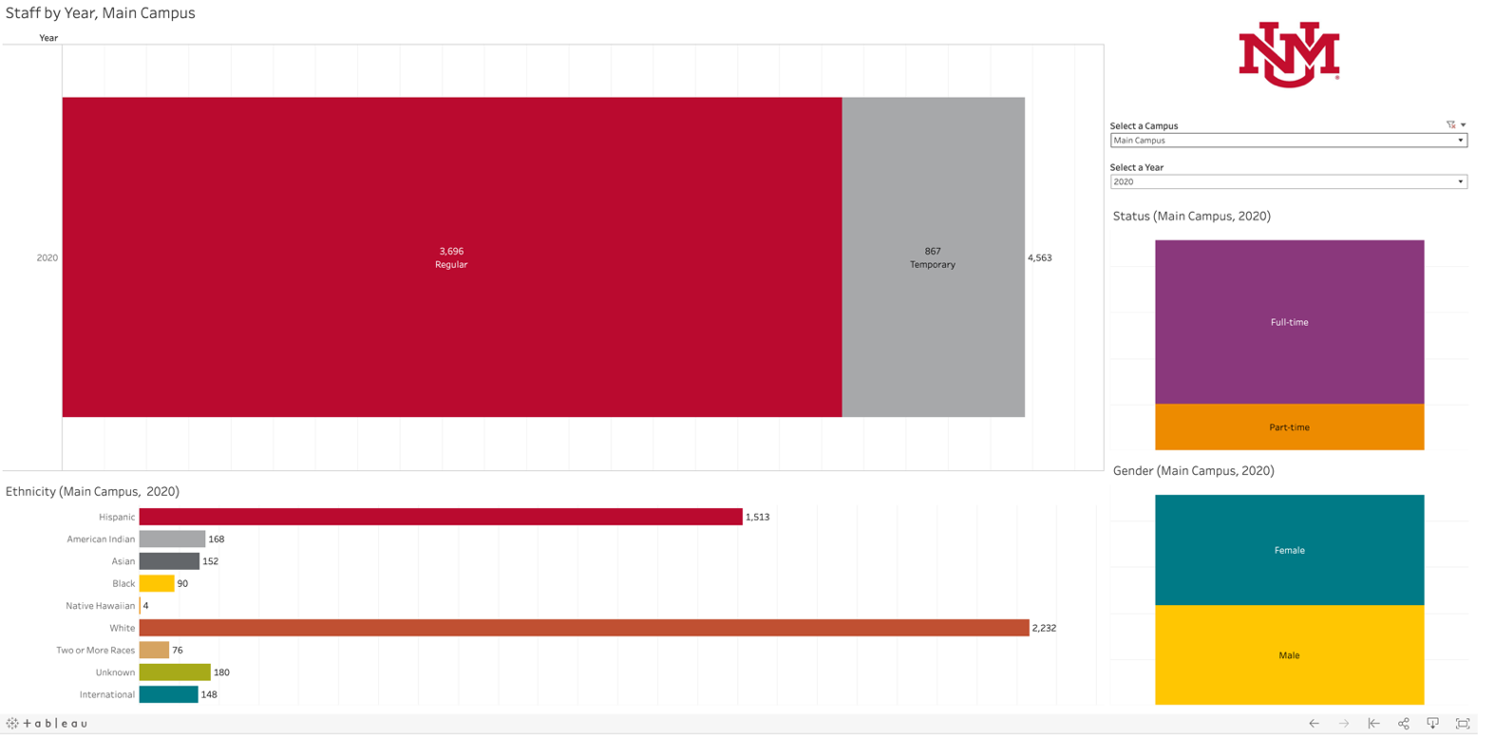

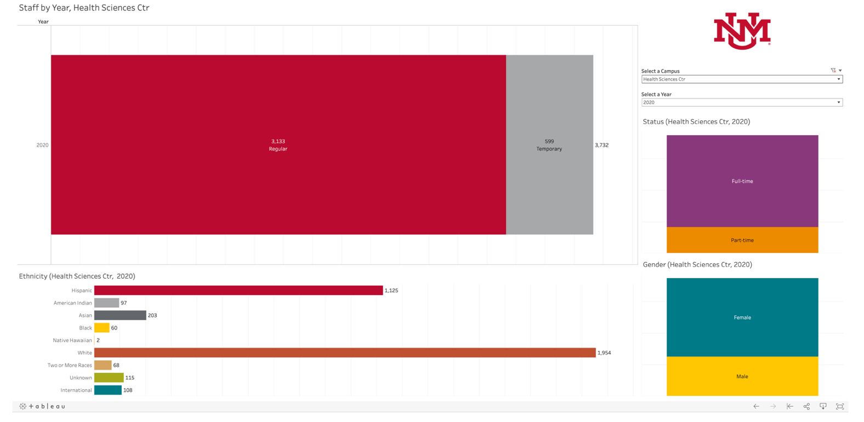

Table . Staff Demographic Data

## IMPROVING CLIMATE

The Division for Equity and Inclusion works to improve our campus climate in a variety of ways. Our work addresses the transformation of environments impacted broadly and systemically by various forms of hate and discrimination including but not limited to: racism, sexism, transphobia, homophobia, Islamophobia, anti-Semitism, ableism, colorism and classism. Through research, education, reflection and collaboration, we seek justice for harms against all our communities.

### SURVEYS

In addition to RIMA survey (described on pages 24-25 above), DEI will partner with the Office of Institutional Analytics (OIA) to administer quadrennial university-wide climate surveys for all UNM students, staff and faculty, starting 2022-23. Modeled on the publicly available University of Michigan Campus Climate Survey on Diversity, Equity and Inclusion, the UNM DEI Climate surveys will focus on climate at each campus. Colleges and departments/units may opt in to department-focused climate surveys that we can make available during the 4 semesters we are not administering and/or preparing for or analyzing the UNM DEI Climate survey.

UNM is committed to institutional accountability to improve inclusive culture at each of its campuses. Climate surveys are an excellent way to chart progress in our efforts and to point up systemic concerns so that they can be addressed. For example, the RIMA survey has provided evidence that our students who are persons with disabilities are experiencing ableism and microaggressions related to their disability status. Learning this has helped DEI to work with the Accessibility Resource Center (ARC) and other campus partners to create workshops to make students, faculty and staff aware of implicit bias and microaggressions for which PWD are targets, and more importantly to practice interrupting these microaggressions.

It is our hope, with the UNM DEI Climate survey that we can become aware of other systematic concerns so that we can address them and demonstrate that each of us defines all of us.

***Recommendation***: Request that all leadership commit to creating diversity statements and set diversity goals in their respective units.

### CAMPUS SAFETY

***Current Situation:*** DEI representatives are currently serving on the UNM Campus Safety Council, the search committee for the new UNM Police Chief, the UNMPD Community Policing Advisory Board, and DEI also serves as a liaison between UNMPD and various student services and groups at UNM. DEI has begun interactions with Albuquerque Police Department (APD) by attending the APD Townhalls in Spring 2021 and providing feedback to the City of Albuquerque (CABQ) Office of Equity and Inclusion (OEI). And DEI has worked to provide resources concerning campus safety and policing at the *Promising Practices in UNM Campus Public Safety Town Hall* <http://diverse.unm.edu/resources/videos.html> and via the Diversity Council’s Restorative Justice and Inclusive Climate Sub-Committee <https://diverse.unm.edu/programs/initiatives/diversity-council/diversity-council-subcommittees.html>. DEI will continue its work to help campus partners imagine and realize solutions that address issues of public safety on campus while balancing the wellbeing of all students, faculty and staff at UNM.

***Immediate Action Items:***Continue to work as a liaison to student groups and student services to build stronger relationships between UNMPD and students, faculty, and staff at UNM. Strengthen UNMPD Community Policing Advisory Board to ensure it is addressing concerns from UNM students, faculty, staff, and community, with special emphasis on issues expressed by BIPOC, PWD, and LGBTQIA individuals. Explore possibility to work with appropriate community and university partners (including UNMPD), OEI, APD, Bernalillo County Sheriff’s Office (BCSO), and other area law enforcement to create an ABQ Community Coalition to facilitate open dialogue and work on joint projects to address excessive use of force and other community concerns.

***Long-Term Action Items:***Implement an active and impactful UNMPD-ABQ community campus safety protocol. Implement the ABQ Community Coalition. Explore needs for campus safety support at UNM Gallup, UNM Los Alamos, UNM Taos, & UNM Valencia.

### BUILT AND VIRTUAL ENVIRONMENT

***Current Situation:*** At UNM, DEI has worked with numerous campus partners to address diversity, equity, accessibility and inclusion concerns related to the physical-built and virtual environment including addressing accessibility, the University seal, Adams mural, building names, prayer spaces, lactation spaces, signage for universal and gender-neutral restrooms, and creating a process for receiving requests for investigating and addressing the physical and virtual climate.

***Immediate Action Item:***Assess UNM’s progress concerning the Adams mural occlusion at Zimmerman Library, addressing building names, removal of old seal signage, and other concerns raised in spaces delineated above. Create an internal DEI process for receiving requests for investigating and addressing built and virtual environment that directs individuals to responsible parties at UNM and provides a “warm handoff”.

***Long-Term Action Item:***Consider setting up a link for addressing built and virtual environment concerns on DEI website and delineate a deliberative process that can be followed to address concerns when an inclusive process is warranted.

### DEI EXPANSION TO ENHANCE SUPPORT TO STAFF AND FACULTY WHO EXPERIENCE BULLYING, DISCRIMINATION AND HARRASSMENT, INCLUDING SEXUAL HARASSMENT

***Current Situation:*** Building on UNM’s sustained engagement with addressing sexual assault under the Department of Justice Settlement Agreement (2016-2019), as well as UNM’s participation since 2019 in the National Academies for Science, Engineering, and Medicine’s (NASEM) Action Collaborative for Preventing Sexual Harassment in Higher Education, in 2020 the Division for Equity and Inclusion inaugurated a new faculty administrative position to locate and sustain that work within DEI. The portfolio of the new Associate Vice President for Equity and Inclusion (AVPEI) consists of leading UNM’s participation in the Action Collaborative and implementing UNM programs inspired by the research and best practices developed through this four-year, national initiative. In addition, the AVPEI assists the Division in leading campus initiatives to promote an inclusive climate within academic units (such as Diversity and LEAD Councils), and contributes to developing administrative capacity to support faculty targeted by sexual harassment, bullying, and discrimination (in cooperation with Staff Council, campus Advocates, and Ombuds Services). Through this appointment, the Division for Equity and Inclusion seeks to increase faculty/staff access and belonging at UNM by centering BIPOC, LGBTQIA, and PWD in UNM’s response, an approach grounded in intersectional and feminist critiques of compliance-based systems and inspired by recent work in “institutional courage” (Freyd, 2019). Success in these projects will rely on the cooperation of existing service units – from academic affairs to compliance and advocacy – to design, implement and evaluate sustainable and research-based interventions that will more effectively prevent and remediate sexual harassment, bullying, and discrimination experienced by staff and faculty (Hutchison, 2020).

***Immediate Action Items:***Develop and disseminate the Staff-Faculty Wayfinder Webpage, which will lower barriers for staff and faculty to access campus and community services responsive to bullying, discrimination, and sexual harassment; facilitate users’ private exploration of intersectional harms and resources; enhance self-efficacy through information and guided referrals; and promote staff and faculty participation in formal and informal conflict resolution processes. In coordination with relevant academic units and guidance from NASEM staff, develop a visiting speakers’ series to present the newest research on sexual harassment that centers BIPOC, SOGIE, and PWD communities at UNM.

***Long-Term Action Item:*** Together with the Director of the Office for Compliance, Ethics, and Equal Opportunity, DEI will develop a high-level Council to integrate UNM’s existing conflict management systems by improving communication and fostering improvements among relevant administrative and service units.

## APPENDIX

### DEFINITIONS: UNM DEI and OIA Racial/Ethnic Definitions follow.

**U**nderrepresented **R**acial/Ethnic **M**inority (URM) includeNative/American Indian**,** African American/Black**, or** Latinx/Hispanic (regardless of racial identification)**.**

**I**nternational **refers to the** federal designation of “Nonresident alien”: “A person who is not a citizen or national of the United States and who is in this country on a visa or temporary basis and does not have the right to remain indefinitely. Note: Nonresident aliens are to be reported separately in the places provided, rather than in any of the racial/ethnic categories described above.”“A person who is not a citizen or national of the United States but who has been admitted as a legal immigrant for the purpose of obtaining permanent resident alien status…are to be reported in the appropriate racial/ethnic categories along with United States citizens”(source: <https://nces.ed.gov/ipeds/report-your-data/race-ethnicity-definitions>).

First-generation college students are defined as students who grew up in a household where parent/guardian did not complete a baccalaureate degree. It is important to note the limitations of this categorization which may include students where no parent had more than elementary school or both parents earned 2-year degrees or dropped out in their last semester of their four-year college. Parental educational attainment as a measure of childhood socioeconomic status is useful for providing equitable opportunities for all our students (Morgan et al., 2021). It is important not to distinguish between first generation college status and low income. While some programs use these statuses interchangeably, we intentionally do not flatten the difference between growing up in a low-income household and growing up in a household where no parent earned a 4-year college degree. Though both statuses are associated they are not analytically equivalent.

Continuing-generation college students are defined as those students who grew up in a household where at least one parent/guardian completed a baccalaureate degree. This is an important measure as research has found that faculty are 25 times more likely to have a parent with a Ph.D. than the general public (Morgan et al., 2021).

Note that undocumented citizens are not able to select racial/ethnic categories. According to HM (4/21/20), “their IPEDS ethnicity will be listed as ‘non-resident alien’ because of their citizenship status”. At UNM, we use “international” designation instead of ‘non-resident alien’. International faculty usually switch to a racial category within a year or two of their academic appointment at UNM. However, there are some who do not switch. For example, in our Main Campus employee data, of “international faculty who started here 2014 or later, 21 of them who are still here changed their ethnicity to something else when their immigration status changed. (4 Hispanic, 9 Asian, 5 White, and 3 Unknown). Thirty faculty who started at UNM 2014-2018 are still here as of Fall 2019 and have not changed their immigration status (thus, their ethnicity is listed as International).”

“Islamophobia is anti-Muslim racism…a fear, hatred, or prejudice toward Islam and Muslims that results in a pattern of discrimination and oppression. Islamophobia creates a distorted understanding of Islam and Muslims by transforming the global and historical faith tradition of Islam, along with the rich history of cultural and ethnic diversity of its adherents, into a set of stereotyped characteristics most often reducible to themes of violence, civilizational subversion, and fundamental otherness. Islamophobia must also be understood as a system of both religious and racial animosity that is perpetuated by private citizens as well as cultural and political structures” (source: Council on American-Islamic Relations (CAIR) <http://www.islamophobia.org/research/islamophobia-101.html>).

Anti-Semitism: Hostile beliefs and behavior towards Jews because they are Jewish. May take the form of religious teachings that proclaim the inferiority of Jews, for instance, or political efforts to isolate, oppress, or otherwise injure. May also include prejudiced or stereotyped views (source: Anti-Defamation League <https://www.adl.org/anti-semitism>).

TABLES & FIGURES

Figure 1. Defining Diversity

Table 1. University of New Mexico, Main Campus Underrepresented Racial/Ethnic Minority (URM) Tenure-System Faculty, October 2020.

Table 2. Inclusive Excellence Postdoc and Visiting Scholars Program and Inclusive Excellence bridge funding to support hiring of URM tenure-track faculty

Table 3. Graduate Enrollment by Race, Ethnicity (Graduate programs including Law, Medical, Pharmacy, Certificate, Masters)

Table 4. Graduate Enrollment by Race, Ethnicity (Graduate, PhD)

Table 5. 2018, 2019 Graduate Enrollment and Doctoral Degrees Conferred

Table 6. UNM Main Campus five-year BA degrees 2015-2020

Table 7. Staff Demographic Data

### REFERENCES:

ASA. 2020. Reconsidering the Use of the Graduate Record Examination (GRE) in Graduate School Admissions Decisions. Washington DC: American Sociological Association (ASA).

Bell, S. T., A. J. Villado, M. A. Lukasik, L. Belau, A. L. Briggs. 2011. Getting specific about demographic diversity variable and team performance relationships: A meta-analysis. J. Manage. 37, 709–743.

Boveda, M., & Weinberg, A. E. 2020. Facilitating Intersectionally Conscious Collaborations in Physics Education. *The Physics Teacher*, *58*(7), 480-483.

Collins, P. H. 2007. Pushing the boundaries or business as usual. *Race, class, and gender studies in sociological inquiry. In C. Calhoun (Ed.), Sociology in America: A history*, 572-604.

De Vaan, M., D. Stark, B. Vedres. 2015. Game changer: The topology of creativity. Am. J. Sociol. 120, 1144–1194.

Dwyer, Elizabeth. 2018 “Giving back, for generations to come: UNM Alum gifts endowed professorship in Sociology, May 10.

Freyd, Jennifer J. & Alec M. Smidt (2019) So you want to address sexual harassment and assault in your organization? Training is not enough; Education is necessary, Journal of Trauma & Dissociation, 20:5, 489-494, DOI: 10.1080/15299732.2019.1663475

Garcia-Olp, M., Nelson, C., Hinzo, A., & Young, D. A. (2020). Indigenous Epistemologies: Implementing Indigenous Practices and Perceptions to the Area of STEM. *Curriculum & Teaching Dialogue*, *22*.

Herring, C. 2009. Does diversity pay? Race, gender, and the business case for diversity. *American Sociological Review*, 74(2), 208-224.

Hancock, A. M. 2016. Intersectionality: An intellectual history. Oxford University Press.

Hofstra, Bas, Vivek V. Kulkarni, Sebastian Munoz-Najar Galvez, Bryan He, Dan Jurafsky, Daniel A. McFarland. 2020. “The Diversity–Innovation Paradox in Science”. Proceedings of the National Academy of Sciences Apr 2020, 117 (17) 9284-9291. DOI:10.1073/pnas.1915378117

Hutchison, Elizabeth Quay. 2020. “Making Campus Safer: Academics Fighting Sexual Violence and Sexual Harassment,” in Flores and Olcott, eds. *The Academic’s Handbook* (Durham, Duke University Press).

Lermusi, Yves. 2013. Confirmation Bias Can Get in the Way of Smart Hiring Decisions. . <https://www.ere.net/confirmation-bias-can-get-in-the-way-of-smart-hiring-decisions/>

López, Nancy. 2021. Can intersectional analysis of Graduation advance race-gender-class equity in higher education? Evidence from a Hispanic Serving Institution (HSI) in the Southwest. March 11, Last accessed 3/30/21 at:  
[https://www.youtube.com/watch?v=caRvrK5uMZI&t=1015s](https://nam01.safelinks.protection.outlook.com/?url=https%3A%2F%2Fwww.youtube.com%2Fwatch%3Fv%3DcaRvrK5uMZI%26t%3D1015s&data=04%7C01%7CKari.Dockendorff%40colostate.edu%7C1a9c880a84684fa75f4b08d8e893de19%7Cafb58802ff7a4bb1ab21367ff2ecfc8b%7C0%7C1%7C637515069082319743%7CUnknown%7CTWFpbGZsb3d8eyJWIjoiMC4wLjAwMDAiLCJQIjoiV2luMzIiLCJBTiI6Ik1haWwiLCJXVCI6Mn0%3D%7C1000&sdata=%2BdQl8E20Qld3BG4aWRwwi%2BvBUQiU1fFVeBzGhR7jZrU%3D&reserved=0)

López, Nancy, Christopher Erwin, Melissa Binder and Mario Chavez. 2018. “Making the Invisible Visible: Advancing Quantitative Methods Through Critical Race Theory and Intersectionality for Revealing Complex Race-Gender-Class Inequalities in Higher Education, 1980- 2015.” Special Issue: QuantCrit: Critical Race Theory and Quantitative Research Methods, *Race, Ethnicity and Education, 21(2):180-207.*

López, Nancy, [Edward Vargas](https://journals.sagepub.com/doi/10.1177/2332649217708798), [Melina Juarez](https://journals.sagepub.com/doi/10.1177/2332649217708798), [Lisa Cacari-Stone](https://journals.sagepub.com/doi/10.1177/2332649217708798), [Sonia Bettez](https://journals.sagepub.com/doi/10.1177/2332649217708798). 2017. What’s Your “Street Race”? Leveraging Multidimensional Measures of Race and Intersectionality for Examining Physical and Mental Health Status among Latinxs. *Sociology of Race and Ethnicity*. 4(1), 49-66.

Loyd, D. L., Wang, C., Phillips, K. W., & Lount, R. (2013). Social category diversity promotes premeeting elaboration: The role of relationship focus. *Organization Science*, 24, 757-772.

McCall, L. 2005. The complexity of intersectionality. *Signs*, *30*(3), 1771-1800.

McLeod, P. L., Lobel, S. A., & Cox, T. H. (1996). Ethnic diversity and creativity in small groups. *Small Group Research*, *27*(2), 248-264.

Moody, JoAnn. 2010*. Rising above Cognitive Errors: Guidelines for Search, Tenure Review, and Other Evaluation Committees*. <http://www.ccas.net/files/ADVANCE/Moody%20Rising%20above%20Cognitive%20Errors%20List.pdf>

Morgan, A., Clauset, A., Larremore, D., LaBerge, N., & Galesic, M. (2021). Socioeconomic Roots of Academic Faculty.

NSF. 2020. ADVANCE: Organizational Change for Gender Equity in STEM Academic Professions. <https://www.nsf.gov/funding/pgm_summ.jsp?pims_id=5383>

Riegle-Crumb, C., King, B., & Irizarry, Y. (2019). Does STEM stand out? Examining racial/ethnic gaps in persistence across postsecondary fields. *Educational Researcher*, *48*(3), 133-144.

Sáenz, R., & Morales, M. C. 2015. Latinos in the United States: Diversity and change. John Wiley & Sons.

Society of Professionals in Dispute Resolution. (2001). “Designing integrated conflict management systems: Guidelines for practitioners and decision makers in organizations” (Cornell Studies in Conflict and Dispute Resolution. No. 4). Ithaca, NY: Cornell/PERC Institute on Conflict Resolution and Washington, DC: Association for Conflict Resolution. http://digitalcommons.ilr.cornell.edu/icr/2.

Society of Women Engineers (SWE) and ARUP. 2014. *Diversity and Inclusion*. Edited by Erin McConahey, Katherine Prater, and Jesse Vernon.

Sommers, S. R. 2006. On racial diversity and group decision making: Identifying multiple effects of racial composition on jury deliberations. *Journal of Personality and Social Psychology*, 90(4), 597-612.

Van Dijk, H., Meyer, B., van Engen, M., & Loyd, D. (2017). Microdynamics in Diverse Teams: A Review and Integration of the d=Diversity and Stereotyping Literatures *Academy of Management Annals*, *11* (1), 517-557.

Worthington, R.L. 2012, “Advancing Scholarship for the Diversity Imperative in Higher Education: An Editorial,” *Journal of Diversity in Higher Education*, 5, p. 2. Copyright 2012 by the National Association of Diversity Officers in Higher Education.

Yuval-Davis, N. (2011). The Politics of Belonging: Intersectional Contestations. Sage.

Zerai, Assata. 2016. *Intersectionality in Intentional Communities: The Struggle for Inclusivity in Multicultural U.S. Protestant Congregations.* Lanham, MD: Rowman And Littlefield, Lexington Books. [https://Rowman.Com/Isbn/9781498526425/Intersectionality-In-Intentional-Communities-The-Struggle-For-Inclusivity-In-Multicultural-U.S.-Protestant-Congregations](https://rowman.com/ISBN/9781498526425/Intersectionality-in-Intentional-Communities-The-Struggle-for-Inclusivity-in-Multicultural-U.S.-Protestant-Congregations)

Zerai, Assata. 2021. A Toolkit for Mentors to Interrupt Racial and Intersectional Microaggressions and thus Reduce Negative Impacts on Access to Education for Students who are BIPOC, Latinx/Hispano, AAPI, Persons with Disabilities, Queer, and Transgender. Mentoring Institute 14th Annual Mentoring Conference Plenary Presentation.

Zerai, Assata, Nancy López, Teresa Y. Neely, Heather Mechler, and Mónica Jenrette. 2021. Racial and Intersectional Microaggressions Survey. University of New Mexico, Division for Equity and Inclusion.

Zerai, Assata (forthcoming) “Teaching decolonial research methodology from a student-centered radical Black feminist orientation” in Roshini Pillay, Sharon Moonsami, and Sibusiso Mkwananzi, (editors) *Transforming classroom experiences for helping professions in higher education-global perspectives. Boston:* BRILL publishers. Series: African Higher Education: Developments and Perspectives.

ACRONYMS Used by UNM’s Division for Equity and Inclusion (DEI):

* AAPI - Asian American Pacific Islander
* AASS - African American Student Services
* AISS - American Indian Student Services
* ARC - Accessibility Resource Center
* BIPOC - Black & Indigenous and People of Color to Include Asian/API, Latinx, & Others
* CRSJ -
* DEAI - Diversity, Equity, Accessibility & Inclusion
* FSI - Feminist Research Institute
* FSP - Faculty Success Program of the National Center for Faculty Development and Diversity
* ISRSJ - Institute for the Study of “Race” and Social Justice
* LGBTQIA - Lesbian, Gay, Bisexual/Pansexual, Transgender, Queer/Questioning, Intersex, Asexual
* LEAD - Liaisons for Equity, Advocacy & Diversity Council of Associate Deans for Diversity & related positions
* MSI - Minority Serving Institution
* NCFDD - National Center for Faculty Development and Diversity
* OFCCP - Office of Federal Contract Compliance Programs
* OIA - UNM Office of Institutional Analytics
* PWD - Person(s) with Disabilities/Disabled Persons
* RIMA(s) - Racial and Intersectional Microaggression(s), to include racial, sexual orientation, gender identity and expression, and ableism (discrimination and bias against Persons with Disabilities)
* SHRI – Southwest Hispanic Research Institute
* SOGIE - Sexual Orientation, Gender Identity and Expression
* URM - **U**nderrepresented **R**acial/Ethnic **M**inority, to include Native American/American Indian, Black/African American, & Latinx/Chicanx/Hispano
* VPEI - Vice President for Equity and Inclusion
* VRC - Veterans Resource Center
* WRC - Women’s Resource Center

Diversity Taskforce Strategic Plan Input Draft Date: 7.14.21. For updates, see “UNM 2040 Strategic Plan Diversity Taskforce 7.14.21 PUB.doc”